BERYL WOMEN INC. ANNUAL REPORT – 2019-2020
Overview
Beryl Women Inc. is the longest running specialist domestic violence refuge in the country, marking its 45th anniversary on 8 March 2020. Beryl Women Inc. is a feminist organisation run by women for women and children and has a strong reputation and identity as a courageous service providing crisis accommodation and therapeutic interventions and support to women and children escaping domestic violence. As its mission, Beryl Women Inc. works to end violence against women and children, including Aboriginal and Culturally and Linguistically Diverse women and children.

The Beryl staff have all come from diverse backgrounds and are actively involved in community sector development, awareness raising and advocacy, while providing high quality children's programs, women's programs and wellbeing support. From setting up a new home to navigating complex legal issues, the service supports women and children at all stages of their journey. Our programs are a vital component of the social fabric of Beryl and provide a community for women and children to feel valued and heard, learn, and grow and let go of the shame and struggle in their life. Programs are funded through grants from various sources, philanthropic support and community donations.

During this financial year, Beryl Women Inc. supported 100 women and children, 33 women and 67 children. Of those families, 23% identified as Aboriginal and 32% identified from a Culturally and Linguistically Diverse background.
This year has seen a rise in women and children coming into Beryl from interstate, having crossed the border to seek safety. All have had differing needs and support. Some have been self-referred, others referred with interstate police involvement. Working with the ACT system has proven challenging, with no cross-jurisdictional funding for women moving from one state to another. For women and children in high levels of distress and uncertainty, it is vital they can access service support as needed to ensure safety is maintained for them and their children. As a specialised service, we have an advantage in that we can work collaboratively and closely with other providers to get good outcomes for these families.
Our length of client stays for large families has been concerningly long, with large families that require 4-5 bedrooms waiting up to two years to access public housing. The need for longer-term housing in the ACT that is suitable for large families has been a long-standing issue, as the ACT’s high rents and limited public housing create bottlenecks for specialist domestic violence services. Advocacy in this space has been ongoing and we look forward to additional investment in public housing from the Government to address the needs of these families.
Beryl's trauma-informed practice is embedded in social justice principles and at its core, practises empowerment, respect and cultural understanding. Beryl has contributed in many ways to the ACT community sector to ensure its sustainability and be a strong voice for social justice and equality, such as participating in the following initiatives:
- ACT Government Safer Families Reforms, improving sector responses to family violence
- The Family Safety Hub, an ACT initiative to address family violence supports
- Working within the Alexander Maconochie Centre to address women's needs in prison
- Submission to the Report on Inquiry into Domestic and Family Violence - Policy Approaches
- Participation in the Our Booris Our Way Review, established in January 2018 to address the high numbers of our Aboriginal and Torres Strait Islander children in contact with the child protection system, and
- Supporting the response to the We Don't Shoot our Wounded Report (2009) examining the experiences of family violence of Aboriginal and Torres Strait Islander victims and their access to justice and to services in the Australian Capital Territory.

Beryl has had a strong voice in the Aboriginal community, and has been led by its CEO Robyn Martin, Kamilaroi woman and community leader for over 15 years. Through Beryl's leadership and community connections, Beryl has created an annual NAIDOC event providing a platform for the voices of local Aboriginal women and leaders to come together to be heard, sharing their stories, insights and knowledge with the broader community in the spirit of truth telling and reconciliation. This shows the strength and the power of women coming together to build relationships and understanding between community members and the importance of walking together through common understanding. By walking together, we are stronger and can make cultural change for better social justice outcomes for women and children.

Work relating to the Equal Remuneration Order (ERO) continued this year, with the service seeking to ensure that the current ERO entitlements would be continued in order to support a viable and fair wage system for women working in the Domestic Violence sector. The ERO relates to a 2012 decision handed down by the Fair Work Commission for the social and community services (SACS) industry, which recognised the role gender had played in inhibiting wages growth for the sector. We will continue to hold our governments accountable to ensure that specialist services are funded to include the ERO in future funding models.

Vision
Creating a society free from all forms of domestic violence, discrimination and abuse of power against women and children by challenging systems and structures and empowering the women and children we work with, particularly Aboriginal and Torres Strait Islander and Culturally and Linguistically Diverse people.
Mission
To provide a professional, accountable, trauma-informed specialist domestic violence service that is based in the principles of intersectional feminism, social justice, and reconciliation, and recognises and fosters cultural diversity.
We do this by advocating to bring about change in structural inequalities and racism by ensuring that all women and children from all backgrounds are empowered to have a voice about their lives and their future.
Our Mission this year has continued regardless of the external and environmental challenges that we have faced and despite the barriers that may exist in our systems. Our mission has been embedded in our day-to-day practice, always keeping the women, children and young people we support central to our organisational work.

45 years of Beryl Women Inc.
When looking back at key events in Australian history, 1975 is most often associated with political turmoil in Canberra around the Dismissal and more broadly with an era of significant social change. It was also the year where Canberra’s first women’s refuge was opened on International Women’s Day by suffragette and member of Canberra Women’s Liberation (CWL) and Women’s Electoral Lobby (WEL) Beryl Henderson. 45 years later, much has changed for both Australia and the organisation now known as Beryl Women Inc. One thing that hasn’t is the need for crisis accommodation and practical support for women and children building lives free from domestic violence.

This need was recognised when a committee of CWL and WEL members met in Griffith in mid-1974 to determine how they could address the issue of domestic violence and safe accommodation in Canberra. Inspired by the Sydney Women’s Commission of Inquiry into Violence against Women, and the subsequent squat to establish ‘Elsie’ in Sydney as Australia’s first women’s refuge, this group of women discovered great demand for a similar place in the local community. With the ACT administered by the Federal Government at the time, submissions were prepared requesting government financial assistance for the running costs of a women’s refuge. The newly established Collective was subsequently granted the use of a three-bedroom house in Watson and $4,000 to contribute to running costs of the Canberra Women’s Refuge. Pat Bryant, wife of the Minister for the Capital Territory, gave the keys to the shelter to Beryl Henderson to open it on behalf of the women’s movement.

Since then, our name has changed and so too has our key government funding partner following the move to self-government in the ACT in 1988. Beryl has expanded from one house to multiple properties, with women and children in our service supported by paid professional workers instead of a roster of volunteer women. We have strengthened our focus on working with Aboriginal and Torres Strait Islander women and children as well as women from Culturally and Linguistically Diverse backgrounds, recognising specific cultural, language and economic barriers that are faced when escaping domestic violence. Our governance structure has moved from a collective of women to one with a board, CEO and staff. The various transformations that have happened within the organisation have each brought their own challenges but have also supported Beryl’s longevity and relevance.

The women’s movement itself has also evolved since the Collective began running the refuge in 1975, becoming more inclusive with concepts such as intersectionality gaining prominence in recognising the different forms of discrimination and inequality experienced by women from different backgrounds. Practising from a feminist framework, these discussions and developments have informed the way we work.

While public awareness of domestic violence has increased dramatically over the past 45 years, dedicated women’s refuges continue to operate under significant pressures. Elsie’s refuge, which inspired the establishment of Beryl, was taken over by St Vincent de Paul’s in 2014 as part of NSW Government funding changes. This has left Beryl as Australia’s longest operating women’s refuge, retaining its focus on delivering specialist, trauma-informed domestic violence support beyond just the provision of shelter. The complexity of the systems and experiences being navigated by our clients, as well as the operating environment and increasing demands on the organisation itself, have strained our limited resources and at times prompted difficult operational decisions. Nonetheless, Beryl has continued to evolve and meet the challenges that come as a small not-for-profit working in a high-risk context.

When commemorating our 45th anniversary, it is hard not to be inspired by the many workers, volunteers and clients who have been part of Beryl’s story. Thank you to all those who have come before us. You have enabled us to reach this milestone, and while domestic violence continues to create a need for our service we plan to be here for the years to come.

For more information on our organisation’s journey, you can learn more from the Beryl HerStory Book commissioned for the organisation’s 40th anniversary.

Insert Client ArtWork

CHAIR’S REPORT
On 8 March 2020, Beryl Women Inc. marked 45 years since we first opened our doors as the Canberra Women’s Refuge in 1975. This significant milestone is an extraordinary achievement and a testament to the incredible women who have invested so much in building a safe place for women and children escaping domestic and family violence in the ACT and surrounding region. Beryl is now Australia’s longest operating refuge, transforming the lives of thousands of women and children by providing specialist support to enable and empower them to recover from the impacts of violence and trauma.
In addition to this milestone, we have also celebrated our CEO Robyn Martin’s 20th year with Beryl. Robyn has been a leader not only within Beryl but across the wider community, serving in a range of important roles including on the ACT Domestic Violence Prevention Council and the Our Booris, Our Way Steering Committee. Robyn has had an immeasurable impact on Beryl as an organisation, and we thank her for her service.
While these anniversaries have been a cause for celebration, the 2019-20 year has of course been dominated by unprecedented crises from which Beryl has not been immune. Like the rest of the Canberra region, Beryl was significantly impacted by the summer bushfires and smoke that affected the city’s air quality. This was followed by the onset of the COVID-19 pandemic, which has transformed all of our lives. In this new reality, domestic and family violence may not receive as much coverage as it would otherwise but in fact has been exacerbated by the lockdowns and other stresses brought on by the crisis. We are seeing new layers of complexity in the experiences of our clients but also in our organisation’s operating environment. In recognition of the impacts of COVID-19 on our staff and their workloads, I am pleased that we were able to support additional leave to ensure our organisation continues providing a safe and supportive work environment that prioritises staff wellbeing.
To deliver on our objective of ensuring Beryl remains sustainable, well governed and evidence based, the board has focused on identifying new ways of working during the 2019-20 financial year. At our AGM, we created a new Secretary position to streamline our record keeping and information management processes. We have established a dedicated Finance and Audit subcommittee to strengthen our financial reporting and enhance our focus on risk management and will continue to develop our organisational capabilities through the creation of a focused Human Resources subcommittee. We have also grown our volunteer engagement through the recruitment of a new social media volunteer, and I’d like to thank Emily Van Kesteren for her work during the year to help us amplify our public voice.
As Chair, I would like to acknowledge the ACT Government for its funding support that has enabled Beryl to reach 45 years of supporting our local community. I would also like to thank our generous donors, acknowledged in this annual report, for their contribution to our mission. Your donations make a tangible difference in addressing domestic and family violence, which remains at unacceptably high levels in Australia.
Beryl’s 2020-22 Strategic Plan is focused on empowering the clients we work with while also advocating for the structural and systemic changes needed to create a society free from all forms of domestic violence, discrimination and abuse of power against women and children. It has been a privilege to serve as Chair during the 2019-20 year, and I would like to thank staff and volunteer board members for their work to help Beryl navigate what have been extraordinarily challenging circumstances and position ourselves for the future.
Barbara Klompenhouwer
Chair

TREASURER’S REPORT
2019-20 has been a successful year for Beryl, in terms of our financial position and our financial and risk governance.

Beryl has ended the year in a healthy financial position, thanks to responsible financial management, and the support of our donors, particularly the ACT Government. Sustainable, longer-term financial stability remains a challenge. Beryl’s work relies on our generous funders, and we would welcome expressions of interest from new donors.

2019-20 also saw Beryl strengthen its financial and risk governance. We have established our first Finance and Audit Committee, including an independent accountant. In addition, we have refined our financial reporting and risk management.

Beryl’s 2020-21 budget will position us to respond to growing need during and after the COVID-19 pandemic. We are upgrading older assets such as furniture and security equipment, to keep our residents comfortable and safe. In addition, we are investing in our staff, including through improved IT equipment, to help them support our clients while working flexibly, as required by COVID-19 protocols.

In 2020-21, Beryl will continue to strengthen its financial and risk governance, notably through a review of our financial policies and procedures, to ensure the money we receive delivers the greatest returns for the women and children we serve.

Penny Jones
Treasurer

CHIEF EXECUTIVE OFFICER REPORT
2019-20 has been a challenging year to say the least, with the bush fires, hailstorms and the COVID-19 pandemic all having an impact on the ACT Community and in particular women, children and staff of the service. This has not slowed service delivery down, but changed the way in which we are operating.
COVID-19
COVID 19 has had a far-reaching impact on women and children across the country forced to reside in lockdown with perpetrators. The Counting Dead Women project run by feminist group Destroy the Joint, which tracks deaths through violence, has recorded 39 women as of October 14 2020 who lost their lives since January, including nine killed in May. A national study by the Australian Institute of Criminology found an increase in rates of violence in the home. Conversely the rates of calls to police had reduced, with victims unable to access supports due to restrictions and fear of perpetrators. The study notes that:
“Critically, the COVID-19 pandemic appears to have coincided with the onset of physical or sexual violence or coercive control for many women. For other women, it coincided with an increase in the frequency or severity of ongoing violence or abuse. Two-thirds of women who had experienced physical or sexual violence by a current or former cohabiting partner since the start of the COVID-19 pandemic said the violence had started or escalated in the three months prior to the survey. Similarly, more than half the women who experienced coercive control reported the onset or escalation of emotionally abusive, harassing or controlling behaviours during the COVID-19 pandemic. Although a significant proportion of women did seek help from police, government or non-government agencies and informal sources, many were unable to because of safety concerns. This is consistent with the concerns raised by many in the support services sector that they found it difficult to engage with women during this period of social distancing. It also helps to explain why the number of domestic violence incidents reported to police has not increased.” (Freeman 2020b).
This study provides the strongest evidence available about the prevalence of domestic violence experienced by Australian women during the initial stages of the COVID-19 pandemic. One in 20 women (4.6%) experienced physical or sexual violence, 5.8 percent experienced coercive control, and one in 10 (11.6%) experienced at least one form of emotionally abusive, harassing or controlling behaviour perpetrated by a current or former cohabiting partner.
Federal and state governments responded with increased awareness raising of supports for victims of violence during the pandemic. Specific funding was also allocated to ensure service delivery did not cease. A total of $150 million was allocated for domestic and family violence by the Federal Government in response to the COVID crisis.
As a crisis service, Beryl was considered an essential service during the pandemic and stayed open for business during the health crisis, ensuring staff and clients were well taken care of and supported.
COVID-19 Service Provision
COVID-19 being declared a pandemic brought a number of challenges for service delivery and staff. While we continued to have a presence on site with a roster of two staff members being on site at any given time and everyone else working remotely, a number of other strategies were put in place to ensure that the service was still operating and providing a service to clients within the boundaries of restrictions.
A number of changes have been made to the ways we work, ensuring that we are maintaining social distancing and putting in place a number of new processes including:
- Working from home checklists.
- Working from home guidelines.
- COVID-19 Risk Assessments for clients.
Other issues around housing, including shared housing, have related to:
- How to manage children whose parent needed hospitalisation
- Alternative accommodation for clients who are instructed to self-isolate when residing in share accommodation
- Managing the risks presented by clients who are continuing to socialise
- Management of client evictions whose behaviour risks the wellbeing of other clients and staff during this time – as safe exits are not obvious when alternative options are not available.
- Upgrading IT system, including upgrading our server
- Purchasing additional laptops

Home schooling and isolation
- Concern regarding unsupervised school aged care (in-home), which could increase risks to children.
- Access to internet, computers/laptops, and sufficient data for share house clients residing in refuge to manage home schooling requirements as well as increased time at the home resulting in higher data usage.
- Financial implications of additional IT support for services.
ACT Government and COVID-19
Support for Homelessness and Domestic Violence Sector Services
In April 2020, Ministers Berry and Orr announced a funding package to support the homelessness and domestic violence sector. A number of initiatives were announced that supported services to continue to operate within a pandemic environment, which eased the pressures that Beryl Women Inc. experienced. The additional funding allowed the service to provide the necessary supports to staff and clients, without creating additional strain on our existing budget.
Homelessness Services (HS) Feedback
The organisation held meetings with Homelessness Services, our funding providers, particularly in regards to the additional responses from the funding body to support organisations through the pandemic. Feedback given recognised the complex work and operating environment to which the service has had to respond:
“I commend Beryl's ongoing commitment and responsiveness to supporting the wellbeing of vulnerable women and children during these challenging times. It remains evident that Beryl continues to provide quality supports which consider a wide range of factors impacting on the safety, health and wellbeing of women and their children fleeing domestic violence.”

Our Booris, Our Way - Interim implementation oversight committee
The Our Booris, Our Way review was commissioned in June 2017 to focus on systemic improvements needed to address the unacceptable overrepresentation of Aboriginal and Torres Strait Islander children in the ACT child protection system. I have been a member of the Steering Committee for the review, providing ongoing input into the review process. The ACT Government received the final Our Booris, Our Way report in December 2019. The report contains an additional 13 recommendations making up 28 recommendations in total.
In recommendation 15, the Steering Committee recommended the establishment of an Implementation Oversight Committee to meet at least on a quarterly basis to receive updates from the Directorate and other relevant parties to address progress and ascertain whether the implementation has stayed true to the original intent of the recommendations.
The ACT Government has agreed that independent, Aboriginal led oversight of the implementation of the Our Booris, Our Way is essential to delivering system reform. The establishment of an Implementation Oversight Committee will be considered through normal Cabinet and Budget processes. In the meantime, the minister has recommended the establishment of an Interim Implementation Oversight Committee.
As with the Our Booris, Our Way Steering Committee, this oversight committee has been established based on the principle of self-determination and will expect real change through full implementation, in a timely manner of all recommendations contained in the final report.
All members of the Committee will be Aboriginal and/or Torres Strait Islander people and will provide a cultural lens to monitoring of implementation against each of the recommendations from the Our Booris, Our Way final report.
Aboriginal and Torres Strait Islander children and their families remain central to the work of the Committee and monitoring of implementation must result in improved outcomes for our community.
Domestic Violence Prevention Council (DVPC) – Aboriginal and Torres Strait Island Reference Group
Much of my time involved with this reference group has focused on hosting a three day community consultation within the Aboriginal and Torres Strait Islander community in relation to the “We Don’t Shoot Our Wounded“ report (2009) and “Change our future. Share What you Know” report (2017).
Both reports highlight the importance of government to address the ongoing impacts of colonisation, dispossession of land and the effects of transgenerational trauma on families with a focus around the disproportionate numbers of families and communities that experience domestic and family violence in the ACT.
In October 2019 Minsters Yvette Berry and Minister Stephen-Smith addressed the ACT Legislative Assembly with a statement acknowledging the past and ongoing work done by the Aboriginal and Torres Strait Islander community in producing the above reports. They also acknowledged the overdue response from the government to the reports.
The focus for the reference group is to seek feedback from the Aboriginal and Torres Strait Islander community to prioritise the 12 recommendations from the two reports, with a view to feeding back to the DVPC and ACT Government. Many of the community members that were children at the time of these reports are now adults. The consultation will consider what has changed for communities since the writing of these reports and how best to move forward to create change for the community.
Inquiry into Child and Youth Protection Services (part 2) Information Sharing under the Care and Protection System
The ACT Legislative Assembly asked the Standing Committee on Health, Ageing and Community Services to inquire into the ability to share information in the care and protection system in accordance with the Children and Young People Act 2008, with a view to providing the maximum transparency and accountability so as to maintain community confidence in the ACT’s care and protection system.
Beryl Women Inc. appeared before the committee and raised a number issues based on our experiences when supporting women and their children, telling the Committee that Aboriginal and Torres Strait Islander children are over-represented across the child protection system. Issues raised included that systemic unconscious bias seems to play a part when CYPS are working with Aboriginal and Torres Strait Islander families.
We also raised complications that may arise regarding information sharing in court documents, such as affidavits, which may place women and children at risk where domestic violence is also a consideration in care and protection matters. There have been instances where women’s privacy and confidentiality have been placed at risk where information sharing occurs in legal matters.
Our experience has been that information sharing between CYPS and our service is limited. What we also know and have seen is that the information being provided to clients in the service is also limited, with decisions being made in the background. Women are not being consulted around what is best for their child or children. We are trying to advocate and serve as a go-between between the client and CYPS but we are not being able to access that information either, or the supports.
The Committee made 44 recommendations relating to changes in the Children’s Act.
HESTA Community Sector Awards
Beryl was announced as one of the eleven finalists in the 2019 HESTA Community Sector Care Awards in recognition of the great contributions that the service has made for our clients, our workplace and to the broader community.

We attended the awards dinner in November 2019, where the winners were announced. Unfortunately we were unsuccessful, but were grateful for the nomination and the recognition of the difference that the service makes to women and children escaping domestic and family violence.

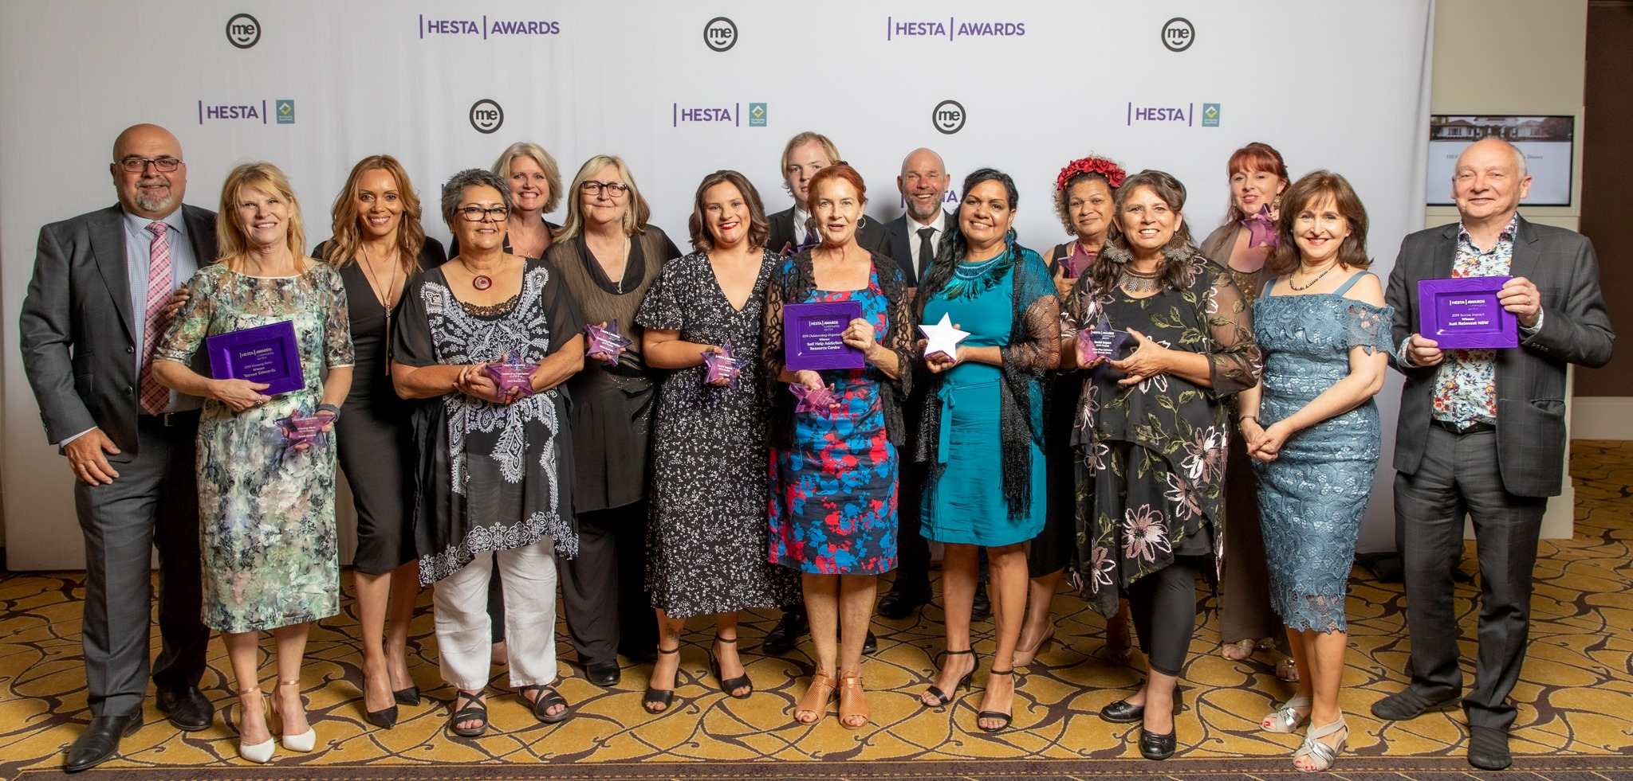HESTA Community Sector Care Awards Celebration November 2019·

Uber Rides and Telstra Safe Connections Program
This financial year the service has had the valuable support of the WESNET (The Women’s Services Network Inc.) Telstra Safe Connections Program. The program provides Tech Safety Training to staff, access to new Telstra Mobile phones for clients escaping domestic violence in need, and provides funding for Uber rides to clients needing safe transportation. The Tech Safety Training ensures staff are up to date with the current technology and can provide safety focused education to women and young people so that they can participate and access technology and still maintain their privacy and safety. It also provides education to reduce technology facilitated abuse to victims and provides phone support to Domestic Violence Workers where technology facilitated abuse is a concern. The Uber rides have ensured staff and clients can attend to appointments with consideration to safety and privacy. This has also had a positive impact on service delivery during lock down and COVID, ensuring essential needs were provided for clients.
Alexander Maconochie Centre AMC
In collaboration with the Women's Centre for Health the organisation has had a women’s worker having regular visits with a small group of women incarcerated at the AMC. We have provided sensitive and trauma informed group work to support women to reflect on the impacts that their history of domestic violence has had on their lives, and aim to increase their skills in managing future relationships and understandings around grief, loss and trauma.
Feedback from the women has been positive, and we hope to see the group continue for this marginalised group of women in the ACT.

Robyn Martin
CEO

SERVICE DEMOGRAPHICS - WOMEN AND CHILDREN WE SUPPORTED THIS YEAR
During 2019-20, Beryl supported 100 clients.
Of the 100 clients, 33 were women. Six of those women had no accompanying children.
Seven of the women were 25 years of age or under
53% of clients were 9 years of age and under
14 families had three or more children
Two women had babies while with the service.
45% of clients had experienced homelessness, with between 1 to 12 months since they last had a permanent address.
23 families (73 clients) were accommodated during this financial year, one family of 2 had 2 separate accommodation periods and two families have now been in Beryl accommodation for over 2 years due to no available exit points. Both families have a priority housing application approval for over 12 months, waiting for larger (4 & 5) bedroom properties.
The remaining 27 clients supported received outreach support only. Some of the (73 clients) also received outreach support once they had secured independent housing.
Cultural Breakdown
(23%) identified as Aboriginal
(32%) identified from a Culturally and Linguistically Diverse background
(45%) identified as Anglo
15% of clients were from South Sudan
25% of clients have English as a second language
GRAPHS

CLIENTS
100 women and children accessing Beryl in 2019-20
33 women and 67 children
TOTAL NUMBER OF SUPPORT DAYS THIS FINANCIAL YEAR – 18,064
Crisis Accommodation – 6,965 days
Transitional Accommodation – 3,642 days
Preventative, Maintenance and Outreach – 7,457

Case Study 1
The Woman and her two-year-old daughter were initially referred to Beryl by Onelink. She disclosed that she had been living in her car for two nights as her previous arrangement had broken down, so we referred her to the Domestic Violence Crisis Service (DVCS). DVCS brokered her motel room for the weekend and we offered her supported accommodation within Beryl Women Inc. The Woman had escaped from interstate due to domestic violence and had fled to Canberra for family support.
The Woman requested assistance to apply for ACT Housing. The other area of support offered to the Woman was to support the child to access Therapy ACT as the child had significant developmental delays. The child was not communicating verbally or using any speech other than the occasional grunts or groans.
Support was offered with a referral to legal aid regarding custody and family law as the father of the child was still residing interstate. The child’s father recruited a lawyer who directed the Woman return the child back to interstate as she had fled with the child without the father’s consent.
During the time the family resided with Beryl, the Woman secured public housing within the ACT but unfortunately had been forced by the Family Court to return interstate while ongoing family law processes continued. This case highlights the challenges Women experience if they are attempting to flee domestic violence from interstate. Further, it shows the importance of Women having formal documentation and the burden the system places on women to support their case in Family Court with high levels of evidence to demonstrate domestic violence is occurring. The Woman had sustained ongoing emotional abuse, financial abuse and coercive control in the relationship for years and was dealing with anxiety, panic attacks and mental health difficulties. This highlights the significant obstacles that women and children may face when trying to rebuild their lives free from violence.
CASE STUDY 2
The Woman and her three children aged 3, 2 and 5 years old were referred to our service by CYPS due to their concerns about the safety of the children who were witnessing domestic and family violence. CYPS had concerns about the Mother’s mental health and identified that the father’s use of violence to discipline the children was a further risk factor and CYPS put in a referral to Onelink for accommodation.
The woman and her children arrived at the service in the initial stages of COVID-19 lockdown. Within 24 hours this had broken down, as she was not coping with caring for her children independently. Due to the limited time we were able to work with the Woman, and because of COVID-19 health regulations, we were only able to support her via a referral to the Adult Mental Health Team as she was threatening to self-harm.
With consent from the Woman we notified CYPS, who notified the Police to conduct a welfare check. CYPS decided to collect the children and return them to their father, despite them identifying he posed a risk to the children with his use of violence towards them, which he called discipline. Because of the deterioration of the Women’s mental health she was unable to remain in accommodation with Beryl, as she was too unwell and required admission to the Mental Health Unit.
We provided an acute response to the mental health crisis for the woman to provide a safe outcome for her and her children. However, as a team we had concerns about the children being returned to their father who was identified as a risk factor due to his use of violence towards the children. This case highlights the difficulties when there is a CYPS intervention. Importantly this case shows the difficulty that women and children experience when they are suffering from trauma and abuse in a domestic relationship and the acute response that is at times necessary.

BERYL WOMEN INC. CELEBRATES NAIDOC 2019
NAIDOC week celebrates the history, culture and achievements of Aboriginal and Torres Strait Islander people. It is a great opportunity for recognition of the contributions that our people make to society and this country.
The very powerful theme for 2019 NAIDOC week was ‘Voice, Treaty, Truth. Let’s work together for a shared future’. The theme was a call to action and acknowledges that Aboriginal and Torres Strait Islander peoples have always wanted an enhanced role in decision-making in Australia’s democracy. More specifically, ‘Voice, Treaty. Truth were three key elements to the reforms set out in the Uluru Statement from the Heart. These reforms represent the unified position of First Nations Australians’.
In 2019 Beryl Women hosted an event ‘Voice, Treaty, Truth – Continuing the Conversation,’ bringing together prominent women from the ACT community to lead a panel of discussion on the theme and recognising, valuing and celebrating the courage resilience, activism and leadership of Aboriginal and Torres Strait Islander women.
The discussion centred around the challenges we face working in the community sector, connecting white privilege with unconscious bias and how this can facilitate the systematic racism we see day to day in our work. We were pleased to welcome many colleagues from the government, NGO and community sectors who came to support the event.
Panel members included:
- Louise Taylor (MC) and first Aboriginal Magistrate to be appointed in the ACT Magistrates Court.
- Robyn Martin, CEO Beryl Women Inc.
- Leah House, Traditional Owner and Case Manager, Mulleun Mura Program, Women’s Legal Service
- Karen Parter, Program Manager - The Smith Family, ACT Director - National Aboriginal and Torres Strait Islander Women’s Alliance (NATSIWA) and Board member of Beryl Women Inc.
- Kim Davidson, CEO, Gugan Gulwan

Karen Parter said ‘It was such an honour to sit on a panel with such resilient and inspiring women. As pillars of our society, Aboriginal and Torres Strait Islander Women have played and continue to play active and significant roles at the community, local, state and national levels.”
“Celebrating our strong women gives us the opportunity to put the stories of role models and leaders in front of our people and inspire them to continue.”
Leah House said she hopes that NAIDOC Week “gives people the chance to celebrate Aboriginal culture and talk about all the positive work that is going on, but also a time to reflect on how we can better improve our work in empowering our people.”
Robyn Martin CEO Beryl Women Inc. said that the purpose of hosting these events has been to raise awareness within the Government and community sector as well as raising issues that our clients are experiencing. “It’s honest, raw at times and uncomfortable for non-Aboriginal attendees, we don’t apologise for that, hopefully it prompts people to think about how they engage with Aboriginal workers and clients they are working with, making their workplaces safer which will in turn increase access to those services.”
The 2019 panel discussion was the second such community event organised by Beryl Women Inc. It reflects our organisation’s commitment to advocating for Aboriginal women and children in our service, but also participating in the broader conversations on social justice issues for Aboriginal and Torres Strait Islander communities. Beryl thanks the panellists who so willingly engage, sharing their immense knowledge and personal and professional insights gleaned from years contributing to our region.
FEEDBACK
“Thank you for your follow up. I found the evening to be very humbling and incredibly useful in continuing to further my understanding of the challenges facing Aboriginal and Torres Strait Islander peoples. I also found the strength of the panel members inspiring even while I recognised the burden that each of them and, in fact, all Aboriginal and Torres Strait Islander people carry in supporting their families and broader community. Knowing that attendance was by select invitation prompted me to think about what more I can do to ensure this privilege is respected and I have already reached out to an Aboriginal colleague in Education to identify how I might be able to support the work she is endeavouring to gain further traction with. Thank you for the opportunity to be part of this event and I look forward to continuing conversations about how I can walk alongside Aboriginal and Torres Strait Islander people to lend support to the changes that are needed both here in the ACT and more broadly.”
“I thought the event was fantastic – the insights of the panel had a significant impact on me and I found their stories and examples extremely powerful. They all spoke with such passion and did an excellent job of articulating issues, concerns and opportunities. I will be strongly encouraging other ACT Policing members to attend this event if it is held again in the future.”
“Thanks to Beryl Women Inc. for such a powerful panel discussion. It was a privilege to hear each of the speakers’ stories. As someone who works in a mainstream social justice organisation, it was particularly valuable to learn more about how to work in a way that supports rather than undermines community control and self-determination. The message that stuck with me the most was how, for each of the panel members, the personal and the professional could not be separated. It reinforced how important it is to appreciate the impacts of intergenerational and personal trauma and the heavy emotional demands that people face in their everyday work to support others to heal. Having such an understanding is critical to help ensure mainstream services engage more respectfully with Aboriginal and Torres Strait Islander organisations, workers and community members in a way that supports healing rather than deepening trauma.”

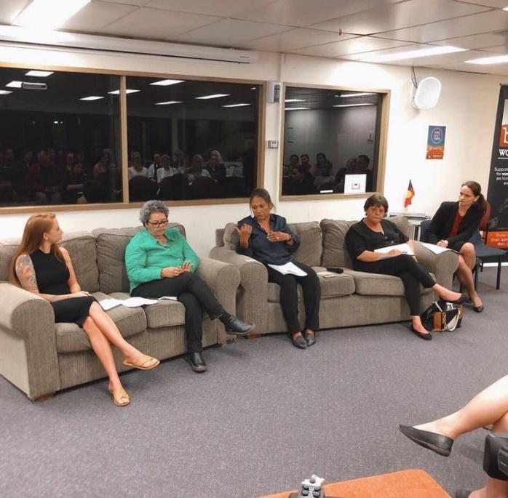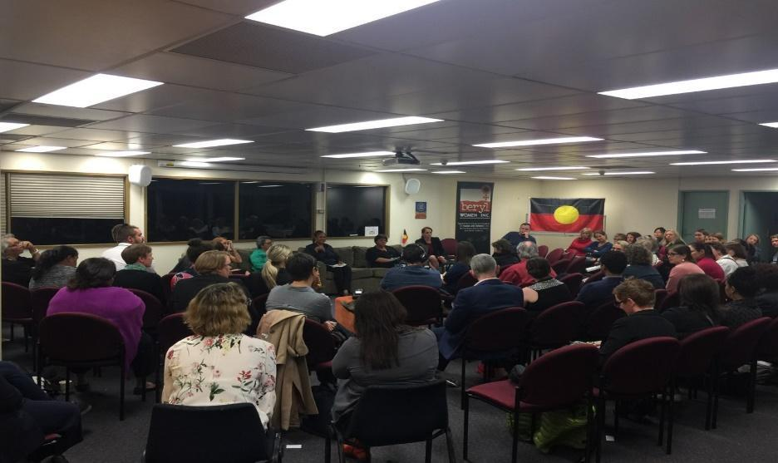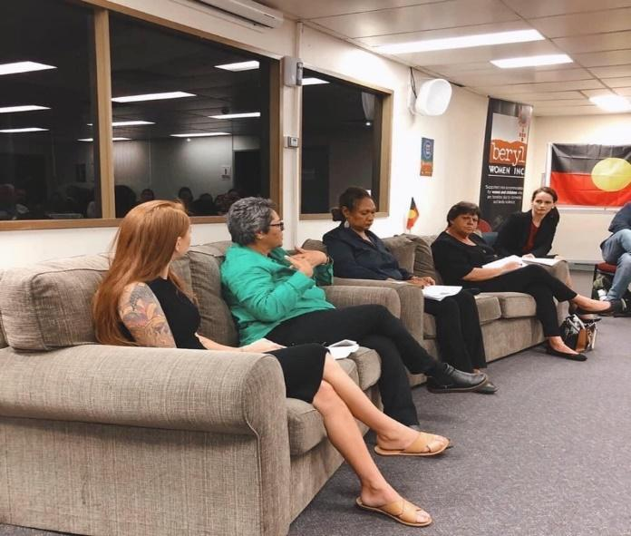

DONATIONS/GRANTS RECEIVED IN 2019-20
Beryl works with many individuals and organisations in the community to ensure we can effectively support women and children escaping domestic and family violence.
We have received record donations during the year ($82,436.65), including from:

- VivCourt
- Erindale Friday Ladies Tennis
- Rotary Club of Canberra Burley Griffin
- Zonta Club
- Environment, Planning, and Sustainable Development Directorate
- The Caps Clinic
- Attorney-General’s Department
- Department of Foreign Affairs and Trade Workplace Gender Equality Network
- Canberra Quilters
- Hays Recruiting
- ANU Medical Students
- Department of Defence – Women’s Leadership Council

Ongoing workplace giving partners include:

- Department of the Prime Minister and Cabinet
- National Blood Authority
- House of Representatives
- Good2give

Acknowledgments and thank you
We would like to specifically acknowledge the support of our funding body the Community Services Directorate and the Social Housing and Homelessness Services staff of the Community Services Directorate.

Other partners we would like to acknowledge include the Domestic Violence Crisis Service; Canberra Rape Crisis Centre; OneLink; Women’s Health Service; Women’s Centre for Health Matters; ACT Legal Aid; Women’s Legal Centre; Street Law; Centrelink Social Workers and Community Contact Officer; ACT Office for Women; Northside Community Services; Relationships Australia; the Snow Foundation; Quest For Life; Commonwealth Bank; Uber Rides and Telstra Safe Connections Program – WESNET; and the many other services that directly or indirectly supported Beryl Women Inc. during the past financial year. We hope to continue to work in collaboration with you all in the coming year.

We would also like to thank the many members of the community who reach out to provide items, donations or other support. This includes Poetry in Flowers, RedFlag Canberra and Simply Giving, as well as several individual members of the community who donate through Workplace Giving or regularly donate via Hands Across Canberra.

HOW CAN YOU MAKE A DIFFERENCE TO BERYL?

The work required to support families fleeing domestic violence and address system improvements is vital and necessary but also highly demanding on a specialist service. Our highly skilled staff team and Board of Management have worked tirelessly this last year in ensuring that our service continues to address the inequities in our system that impact vulnerable families that are building lives free from domestic violence.

You can help us to continue this important work by going to https://www.beryl.org.au/donations and making a donation. All donations are welcome.

Workplace Giving is another option to help provide regular support that makes a real difference to our work.

Beryl works on Ngunnawal land

We wish to acknowledge the Ngunnawal people as the traditional custodians of the land we work on.

We pay our respects to the Elders past, present and future for they hold the memories, the traditions, the culture and hopes of Aboriginal Australia. We remember that the land we work on, was and always will be traditional Aboriginal land.

CLIENT FEEDBACK TO BE PLACED RANDOMLY THROUGHOUT THE REPORT
- “The emergency accommodation provided myself and my kids with a stable environment. The staff went above and beyond to ensure I was assisted with any support that was needed. Staff were always ensuring my family were safe.”

- “I found Beryl Women Inc. and its staff members absolutely supportive. Being at Beryl, not being judged, my confidence and my ability to become more independent has grown a lot. I’m so thankful to everyone who assisted me.”

- “From the start I was made to feel welcome, safe, supported and like a friend, not a stranger.”
- “Beryl has broken the cycle of violence for me, and I am so grateful for them. My children thank Beryl and staff every day, when I ask them what they are grateful for.”

- “OMG, I am still in shock, I think this is incredible. Not only do I suddenly have a house full of items, but it is all so gorgeous, such beautiful furniture in amazing condition. I am feeling incredibly lucky. Didn’t think I’d be getting anything for my birthday, and I’ve been absolutely spoilt rotten by a family I don’t even know.”

- “Thank you so much for everything you guys have brought over for the school holiday program. You’re all angels, you go above and beyond what I ever expected, you change people’s lives and my kids and I are grateful for everything that you do. I don’t even know how to thank you.”

- “The service was amazing at helping and doing what they say. They even went above and beyond in helping me move and source furniture.”

- “Beryl is perfect for kids; my son and I got a better relationship and I had time to reflect on what I needed to do for a better life for me and my son.”

Boxall H, Morgan A & Brown R 2020. The prevalence of domestic violence among women during the COVID-19 pandemic. Statistical Bulletin no. 28. Canberra: Australian Institute of Criminology. https://www.aic.gov.au/publications/sb/sb28

