Beryl Women Inc.

**annual report 2014-15**



Beryl Women Inc.

Support and accommodation for women and children experiencing domestic violence

Office Hours

9-5pm, Monday to Friday

Office (02) 62306900

Fax (02) 62473511

Email [beryl_women@bigpond.com](mailto:beryl_women@bigpond.com)

Website [www.beryl.org](http://www.beryl.org)

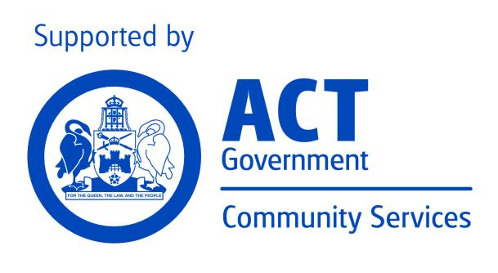

Mission

Beryl Women Inc. is committed to providing high quality support and safe accommodation to women and children escaping domestic/family violence. The organisation recognises that violence against women and children is prevalent in our society and that injustices such as sexism, racism, economic inequality and homophobia contribute to families living in crisis. To redress this, Beryl Women Inc. will provide a professional and accountable service that is based in social justice, recognising and fostering cultural diversity.

Organisational Aim

Beryl Women Inc. aims to contribute to the enhanced safety of the families who stay at Beryl, to their improved health outcomes, and to provide opportunities to increase their skills and confidence to manage future crisis.

Goals of Strategic Plan

July 2013 – June 2016

BERYL WOMEN INC. will be a sustainable organisation that provides high quality domestic violence-specific services to women and children

Through

The development of partnerships and collaboration with other community services and government agencies in order to be part of a holistic response to women and children escaping domestic violence

A strong identity and profile in the ACT community as a feminist organisation offering high quality services



A strong identity and profile in the ACT community as a service that is welcoming of, accessible to, and appropriately supportive of Aboriginal and Torres Strait Islander women and children and women and children from culturally and linguistically diverse backgrounds (CALD)

Being an organisation that encourages a learning culture and is innovative in its response to support women and children escaping domestic violence

Herstory

Originally named the Canberra Women’s Refuge, Beryl was established in a house in Watson in March 1975 with a grant of $4000 from the Department of the Capital Territory. Volunteers, who ran a 24-hour roster, seven days a week, staffed the first refuge. In 1976 the service moved to a duplex in Kingston and sometime later funding was received for employment of a skeleton staff.

In 1976 the service changed its name to Beryl Women’s Refuge, after Beryl Henderson who started the original trust fund for the refuge, which, outside of the $4000 Grant received from the government, was the sole means of supporting the cost of running the service. In 2005 the service changed its name again to Beryl Women Inc.

Beryl Henderson was an active member of the ACT Women’s Liberation Movement and the co-founder of the Abortion Law Reform Association in Canberra. She also worked for Family Planning and the Humanist Society. Beryl taught languages on an Israeli kibbutz in 1960 to 1964 before coming to Australia. She returned to Israel in the late 1970s and died there in her 94th year and will always be celebrated for her dedication and commitment to the cause of equality. Beryl Women Inc. is proud to carry Beryl Henderson’s name as a daily reminder that those wonderful ‘big sisters’ who came before us, made possible the services we have today.

Report from the chairperson

Rhonda Woodward

Chairperson

Beryl Women Inc.

Staff and Governance Committee

As I write this and reflect over the past 12 months, I am reminded of how challenging it is managing a small organisation like ours and appreciate the enormous effort put in by staff and Committee members in ensuring that Beryl Women Inc. continues to provide support to women and children escaping domestic/family violence within a trauma informed framework.

At the time of writing this Annual Report there have been 63 confirmed murders of women at the hands of their partner or ex-partner, leaving many children without a mother, this is all the more reason we need to take a moment, reflect, and focus on the impacts of domestic/family violence on women and children, staff and the broader community.

Without specialist domestic/family violence services like Beryl, the options for women leaving a violent relationship is limited, their continued safety at risk. Beryl provides a safe space for women and children to start the healing process with the support of staff who are non-judgemental, supportive of women’s choices, the refuge provides a space for women to gain a feeling of control over their lives.

There is a need to continue to develop, but how wonderful we have teachers of the calibre of our Senior Sangha and Geshes and their wisdom available to us as resident and visiting teachers and through the Online Learning Centre.  
  
In addition, the extra hours you worked while maintaining the standard of excellence that Beryl is known for in the community and has contributed to better outcomes for women and children.

What a priviledge it is to be a part of such an amazing organisation filled with such amazing people, thank you so much for your dedication and admirable work ethic.

Report from the Manager

This year has been a significant year for Beryl Women Inc., on International Women’s Day, the service turned 40year’s old, launched our book and our re-branding, also I was awarded the ACT Women of the Year award, a privilege and great recognition of the work that I have done over the past 15 years of working at Beryl.

I have included quotes throughout the report from former clients, Collective members, Staff and former staff and former Committee members

I too would like to acknowledge the traditional custodians of the land on which we are meeting today, the Ngunnawal People and pay my respects to the elders, both past and present.

I have worked at Beryl Women Inc. for the past 15 years, 9 of those years in the Manager’s position. In those 15 years, we have supported 806 women and 1546 children, as you can see, children represent over half the number of clients accessing the service. I have seen women and children re-entering our service, and years later, their children with their children entering the service in their own right often referred to as third generational clients.

I want to pay tribute to the women who have accessed the service over that period of time, women who found the courage to leave with their children, often not knowing or having experienced life in a refuge setting before, not knowing what to expect when they first arrive, their trust in the service and workers is incredible. Their strength, courage and resilience is inspiring.

I have learnt lot from these women, I’ve learnt that short-term crisis accommodation alone will not heal the trauma that women and children have experienced, I know that this type of intervention deals with the immediate issue of safety and accommodation but that the long-term effects of trauma cannot be fully healed in such a short timeframe.

The impacts of trauma as a result of violence, especially intimate partner violence, racism, poverty and homelessness cannot be met by short term crisis accommodation, early intervention and prevention programs play a major part in the healing process and needs to be supported by appropriate funding and support from the general community.

But just listening to, and learning from these women is not enough. Up until mid-February, 13 women have been murdered as a result of domestic violence in Australia that we know of. In fact, a woman is more likely to be killed in her own home by her male partner than anywhere else and just recently another death, here in Canberra, my thoughts and prays go to her family.

These numbers are appalling, what disturbs me even more is that it’s happening in a climate when governments are cutting funds, services are struggling to remain viable, forcing smaller specialist services such as Beryl to review how we deliver our service, reducing the level of practical support that Beryl has been known to deliver, current funding and staff levels do not allow for this to continue.

Beryl is funded through the ACT Government under their Social Housing and Homelessness Services through the Community Services Directorate, funded as a homelessness service but our business is supporting women and children escaping domestic and family violence which means our priority is safety and security is paramount , we are dealing with women’s lives which also impacts staff, in 1 month, we had 3 critical incidents where perpetrators of violence turned up at the refuge, one confronting a staff member, these situations remind us that we must remain vigilant when coming and going from the refuge.

One of the other incidents involved a women being tracked to the refuge through an electronic device, men are using modern technology to track women across the country, we have supported a number of women moving from state to state just trying to stay safe.

Beryl is in a unique position to work holistically with vulnerable families due to the supported accommodation nature of the service. In this context, workers are provided with many opportunities to understand what is happening to/for the children. In this way we are better placed than other family support services who may only have contact once a week or so to offer ongoing support and guidance through difficult times. Unique opportunities to engage families, build relationships that promote and enhance a family’s capacities and strengths, present themselves in our daily contact with clients.

Domestic and family violence remains a leading cause of homelessness, we know that it is the leading cause of injury to women, we also know that one in 3 women will experience violence in her lifetime.

Beryl women Inc.’s approach and philosophy, informs our practice, we are a feminist service and although not a collective in the true sense, collectively is still practiced in my management style, we support women and children escaping domestic and family violence within a feminist trauma informed framework, this work cannot be rushed, we do not want to re-traumatise women by being insensitive and disrespectful, we need to develop trusting relationships in order to support women and children through a healing journey. Still today after 40 years, women and children still experience violence and oppression.

Over the past 15 years there have been a number of challenges that the service has faced, numerous funding cuts, reduction in staffing numbers, changes from a collective model of governance to a committee governance, in spite of all the challenges, our long gevity has allowed us to create strong relationships especially with other women’s services, our relationships with the community has grown and as a result we have been the recipients of many donations – large and small, the flow on effect for clients has been huge. These donations come from many sections of the community, too many to many individually, but we thank you and appreciate the support.

One of the things that I have love about working at Beryl, is its commitment to reconciliation and while not funded as a specialist Aboriginal service, the number of Aboriginal clients accessing the service during this time has been high, we work very hard at ensuring that the service is culturally appropriate. Women from a Culturally and Linguistically Diverse background also receive specialist support specific to their culturally needs. Our reputation within the sector and community is that of a service with integrity and culturally sensitive and feedback from women and children support that.

I have worked with many staff members over those years. They have been hard-working, passionate and dedicated to making the lives of women experiencing violence easier and advocating for the rights of women and their children. I have learnt much from them and I thank them for their support, for sharing their knowledge and experiences with me.

I would also like to acknowledge the many women who have been a part of the extended collective and committee, your drive and commitment and leadership has ensured Beryl’s continued survival.

I would also like to acknowledge the current staff members of Beryl, Angie, Jen, Lina and Linda, your passion, commitment and expertise leads to better outcomes for women and children who have and are currently accessing the service, it’s your team approach and dedication that makes a difference in the lives of women and children that hopefully gives them the skills to move on to a life free of violence. I’ve always said that a good leader is only as good as the team standing beside them, you make me look good, for that I thank you.

And finely once again I would like to thank the Honourable Minister Macklin and Minister Berry for being present for our 40th Birthday celebration and launching the Opening a New Door -Herstory of Beryl Women Inc. book and to Farzana and the women who worked tirelessly to pull the book together.

Thank you.

Robyn

Acknowledgments

I would also like to specifically acknowledge the support of our funding body the Community Services Directorate and the Social Housing and Homelessness Services staff of the Community Services Directorate. Other partners we would like to acknowledge are DVCS, CRCS, Toora Women Inc. First Point Central Intake Service, Women’s Services, ACT Legal Aid, Women’s Legal Centre, Street Law, Centrelink Social Workers and Community Contact Officer, Office for Women, Northside Community Services and the many other services that directly or indirectly supported Beryl Women Inc. during the past financial year. We hope to continue to work in collaboration with you all in the coming year.

23 women researched and wrote this book, documenting the Beryl story for the world. They were mostly volunteers from the public service and they care about combating domestic violence and promoting gender equality.

Service Management

Domestic Violence Christmas Crisis Program

Donations

Beryl Women Inc. have built strong relationships in the community and are very grateful to all the individuals and businesses that have provided financial support and support in the way of whitegoods, furniture items, handmade blankets and general household and food items. The website enables the community to have a greater understanding of what our needs are and the ACT Community and individuals from interstate have been extremely supportive of the service this past year. I would like to formally acknowledge and express our thanks particularly to the following;

* Attorney Generals Department for their kind donations through their Workplace Giving Program and food and cleaning packs for women
* Hands across Canberra, for their ongoing support through their community giving portal. With their support we are able to provide emergency food and safety packs and school stationery for children and young people.
* Organisers from the Fruit Tingles Dance Event who have also generously provided funds to the service.
* Eternity Church for their ongoing support and encouragement
* Labour Women for their financial support and donations of hand knitted blankets
* Masters- building materials
* Bunnings Fyshwick- building materials
* DPO Gyprocking – Labour
* Workplace Giving- Aust. Blood Authority

Grants

Training

We are committed to the ongoing training and development of our workforce, aimed at the provision of high quality services for our client group. In keeping with this commitment we have provided staff with a range of training options, detailed below, to enhance and build on their current skills.

Collaborative Working Relationships in the Community

Beryl has been involved in a number of consultations within the ACT community. These ensure that the service is up to date with changes within the sector and importantly continues to maintain strong positive working relationships with Government and Community Services on issues related to Domestic/Family violence, Aboriginal and Torres Strait Islander Women and children and Women from a Refugee Background.

The Manager attended and spoke at the 2013 ACT Roundtable for the Prevention of violence against women and children which was being hosted by ACT Policing. Topics for inclusion in the paper were current successful approaches and strategies in prevention of violence in Aboriginal and Torres Strait Islander and Culturally and Linguistically Diverse Background communities and challenges that exist in preventing violence in Aboriginal and Torres Strait Islander communities and Culturally Linguistically Diverse Background communities.

**ACT DOMESTIC & FAMILY VIOLENCE DEATH REVIEW**

Beryl participated in the ACT Domestic & Family Violence Death Review earlier this year, the ACT Attorney-General requested that the Domestic Violence Prevention Council (DVPC) review closed cases of death in the ACT that occurred within the context of domestic violence since 2000. The review forms part of the ACT Government’s commitment to the *National Plan to Reduce Violence Against Women and Their Children 2010-22* and the *ACT Prevention of Violence Against Women and Children Strategy 2011-2014*. The review aims to provide a robust and independent picture of domestic and family violence in the ACT, inform government decisions about domestic and family violence mechanisms and assist in identifying issues that point to legislative, policy, practice and service changes across the government and community sectors.

**BOUGAINVILLE WOMEN’S FEDERATION**

We were contacted by the Australian Government Department of Foreign Affairs and Trade in relation to a service visit for two prominent Bougainvillean women to Australia during 21 – 26 June. Ms Barbara Tanne, Executive Officer of the Bougainville Women’s Federation and Florence Naina, also with the Federation, The purpose of the trip was to share Australia’s experience with promoting women in leadership, in business and in the community and to provide a network that these women may draw on in the future.

Both women had expressed a particular interest in meeting with women alliances, women’s shelters, and learning more about long term and legal assistance provided to women who face domestic violence.  We recently had contact with the organisation at which time they said that “it was a wonderful time learning from your experiences. BWF is a young learning organisation and your sharing is very much appreciated. I affirm to you all that this meeting has enriched us in a lot of ways”

* Women’s services
* Coming Home Program – Alliance
* Joint Pathways
* Sub-committee 2nd Implementation Plan on the prevention of violence against women and children in the act
* Governance Group
* Snow Foundation – Morning Tea
* ACT Community Sector Multi Enterprise Agreement consultations with ASU and Jobs Australia
* Aboriginal and Torres Strait Islander Whole of Government Agreement consultations
* Domestic Violence Crisis Accommodation Program
* Case conferencing with Care & protection
* Meetings with DOCS - Queanbeyan
* Provided feedback on CSD’s RAP

The service also attended a range of other meetings, consultations, steering groups, launches, rallies and events of significance to our organisation.

Some of these were:

* Women’s services
* Joint Pathways
* Family Pathways Network
* Sub-committee 2nd Implementation Plan on the prevention of violence against women and children in the act
* Governance Group – as above
* Case conferencing with Care & protection
* Meetings with DOCS – Queanbeyan
* Nth Ainslie School – IEC Coordinator re enrolment of child
* Companion House re access to doctor there?
* Focus Migration re immigration issues
* Street Law
* Legal Aide – Application for DVO
* MARS – drivers licence support
* Victims Support – counselling
* Centrelink – Special Benefit application
* Completed Affidavit for 1410 – immigration DV basis
* ANU Migration Law
* Snow Foundation
* DVCS
* ACT Police
* Red Cross

**WESNET/TELSTRA SAFE CONNECTIONS PROGRAM**

As part of the WESNET/Telstra Safe Connections Program, Beryl has been provided with a number of smart phones that will enable clients experiencing domestic/family violence to remain connected with family, friends and service providers. Beryl has already distributed a number of these phones to women accessing the service, one of the criteria for participating in this program is to not just provide the phone but to also provide safety planning around technology abuse, show women how some basic tips about using the smart phones more safely.

Media and raising Community Awareness

Beryl Women Inc. has been involved in a number of awareness raising activities through media and some of those are listed below;

Community Linkages

Links to services and advocacy on behalf of clients have been in relation to specific

support needs:

**DONATIONS**

Increased number of donations of clothing, furniture, white goods and various other items, this influx has been very much appreciated however, we do not have the space to store large items, some of the donated items were accepted sight unseen, this has been problematic as some of these items are in poor condition leaving the service in a position of disposing of the items, costs and time associated with this has had an impact on the service.

A decision has been made recently by the service that we will no longer accept donations of furniture or miscellaneous items as the service does not have the capacity to manage the pick-up, storage and drop-off and delivery. The service will continue to facilitate donations of furniture for clients when clients are able to access transport and storage if we receive offers at the same time that a client has been allocated a property.

There is a voluntary women’s organisation in Queensland called “Assist A Sista”, which I have been talking with Natalie Howson about the need for such a service in the ACT in the hope of having something similar established in the ACT that will benefit women and children leaving specialist domestic/family violence services. This service is run by vulunteers and work directly with women’s refuges in setting up houses for women and children leaving refuge accommodation.

**3 X CRITIAL INCIDENTS**

There have been 3 critical incidents during this reporting period, involving perpetrators of violence;

1. Ex-partner showed up at the refuge, popped his head over the fence as a worker was about to drive a service car out, he was aggressive and demanding a car that the client was driving, worker did not engage with him and continued to drive out of the refuge, whilst calling the refuge to warn them that he was on the premises. Staff proceeded to follow the steps involved in dealing with the threat and to ensure client and worker safety.

Action taken:

* Police were called, they arrived within 4 minutes, perpetrator was handcuffed and removed from the refuge, and no charges were laid, no current DVO in place.
* Service went into “lock down”
* Client was exited due to disclosing the address to perpetrator with support from DVCS
* Clients reminded of confidentiality of address and security within the refuge
* Debrief with clients
* Debrief with staff
* Review of policy and procedures, Risk Management Plan and Business Continuity Plan at staff meeting.
* Place map and procedures on all desks re: response steps required by staff if/when perpetrators on the grounds.

2. Client disclosed address to perpetrator of violence, staff member had noticed him driving around the refuge on a number of occasions, beeping the horn, when he dropped her off at the refuge, and workers heard screaming at front of the property. Client was on foot path screaming at car. Car was reversing up the road. Car left and worker spent some time with client.

**TECHNOLOGY STALKING- CRITICAL INCIDENT**

Suspicious man was seen casing the refuge, a worker saw the car and was able to identify the number plate, it was the ex-partner of a client who was receiving outreach support from the service who was also at the refuge at the time. Police were call but the man left the area as soon as he had seen the police. I was later discovered that the woman was being tracked through an electronic a devise in the boot of her car. The woman did spoke to the police who informed her and staff that nothing can be done as there were no orders in place and woman did not want to put in a complaint.

Only one of Beryl’s staff members have undertaken the Safety net training, offered by WESNET, the training is expensive and the service has limited resources to allow all staff members to attend this type of training although it is vital given the increase in the use of social media and tracking devises that are available.

Client Functions

A number of events have been held during the year involving client participation, following are just some:

Women’s Groups

Services that have attended our Women’s Group this past 12 months.

Outreach Support

Child/Youth Support Program

Service Demographics

Number of clients

In this financial year we supported 141 clients with accommodation and or preventative and maintenance outreach support. This included 51 presenting Units which consisted of 49 women with children, 1 twenty one year old woman and 1 fourteen year old girl.

Beryl Women Inc. provided crisis and medium term accommodation to 115 clients consisting of 42 women and 73 children. This included 1 family with a grandmother accompanying mother and daughter.

This accommodation was provided to 41 presenting units with 42 stays of accommodation.

We provided 9 women with 16 accompanying children and 1 fourteen year old with Outreach preventive support who have not been accommodated at Beryl during this period. Some of these clients had been ex clients from the past and others had not received support from Beryl until this period.

This year we supported 23 clients (16.3% of 141) for which there last permanent address had been interstate.

In many of these cases clients have been advised and provided support from interstate police to relocate out of their home state due to ongoing stalking or high risks of harm to women and children. For these families their trauma may be quite extensive due to a number of factors such as ongoing movement and instability of housing due to breaches to Domestic Violence orders by perpetrators, a lack of continuity of care due to fragmentation of service provision, and inappropriate or unsafe service responses due to insufficient funding.

Schooling may be severely interrupted for children numerous times throughout a year and moving to a whole new area places families at a great disadvantage in accessing supports. Providing a high level of support is necessary for these families to re-settle and recover from the impacts of trauma and violence.

Women from a culturally and Linguistically Diverse Background also tend to stay for much longer periods, have limited English and can have complex visa and immigration issues. This has the effect of short term refuge space being unavailable for other groups of women that tend to stay for shorter periods such as women from an Aboriginal and Torres Strait Islander Background.

Cultural Breakdown

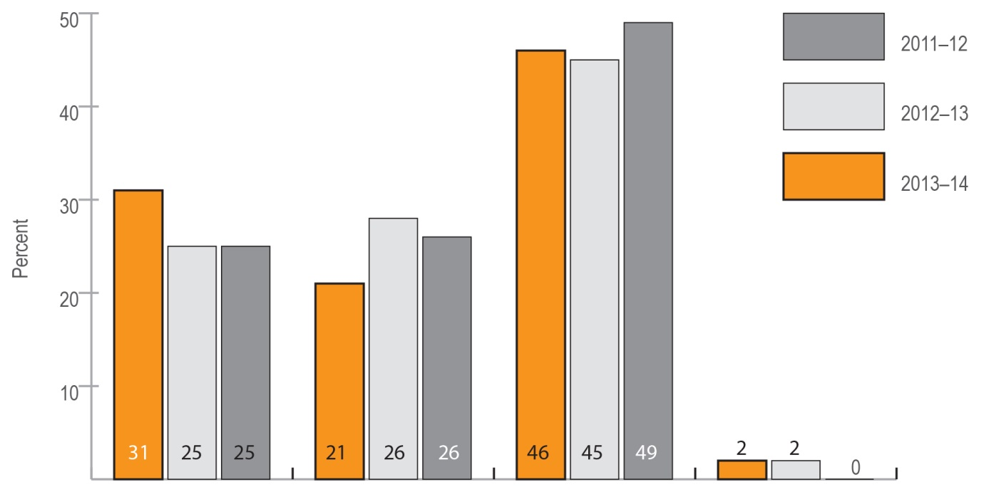CALD 31% (45) Koori 21% (29) Anglo 46% (67)

English speaking not born in Australia 2 % (3).

Overall this year there has been a significant increase in Cald families access support. A very interesting stat for this financial year is that 23 clients ( 16.3% of all clients) were born over seas. This included 18 women and 5 children.

Breakdown of women and children

Accompanying children make up the largest percent of clients accessing the service as shown in the following graph. These children having been directly or indirectly affected by the impacts of domestic/family violence suddenly find themselves in a refuge, disconnected from friends, family and social networks, often having to start a new school and may arrive with few personal belonging. All of these issues can contribute to many of the children experiencing significant loss and grief.

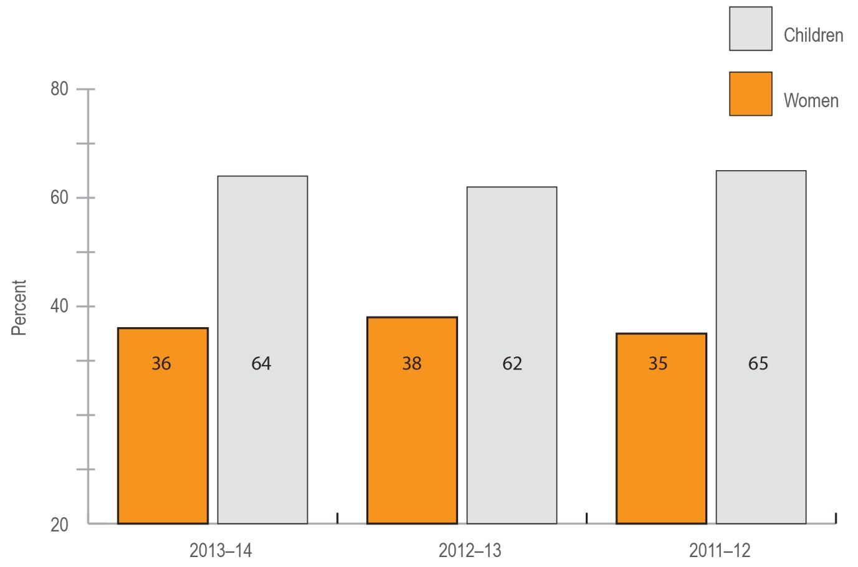

51 women (36% 0f 141) and 90 children (64% of 141). Women include 1 grandmother staying with mother and grand daughter. Some interesting stats for this year are 57 children (63% of 90) were 5 years or under. 15 women (29% of 51) were 36 years or older. 12 women (23.5% of 51) were 25 years or under.

Support Days

This graph show the amount of days of support provided to each client.

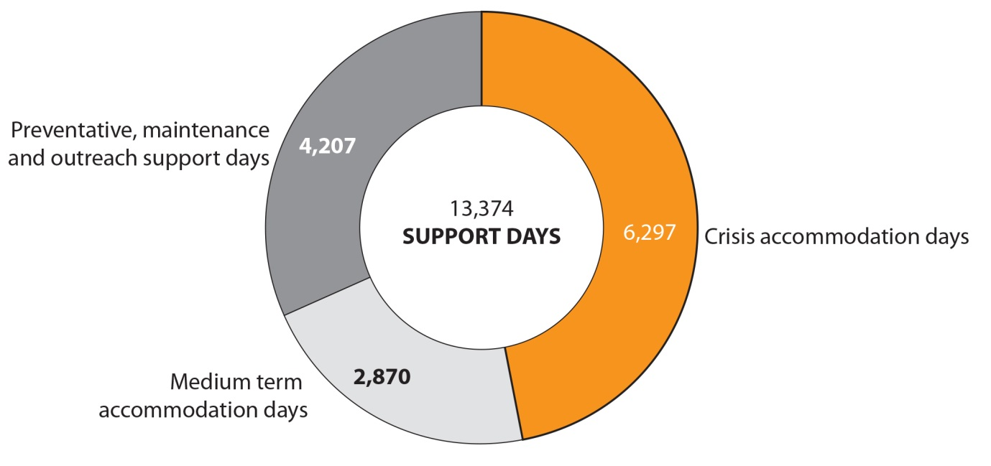

Overall Beryl Women Inc. provided 13374 days of support which includes 6297 days in crisis accommodation, 2870 days in medium term accomodation and 4207 days of preventive, mantaince and outreach support.

Preventive, maintaince and outreach support is available to all clients who have been accommodated at Beryl and move on to independent accommodation for a period of around 3 months if required.