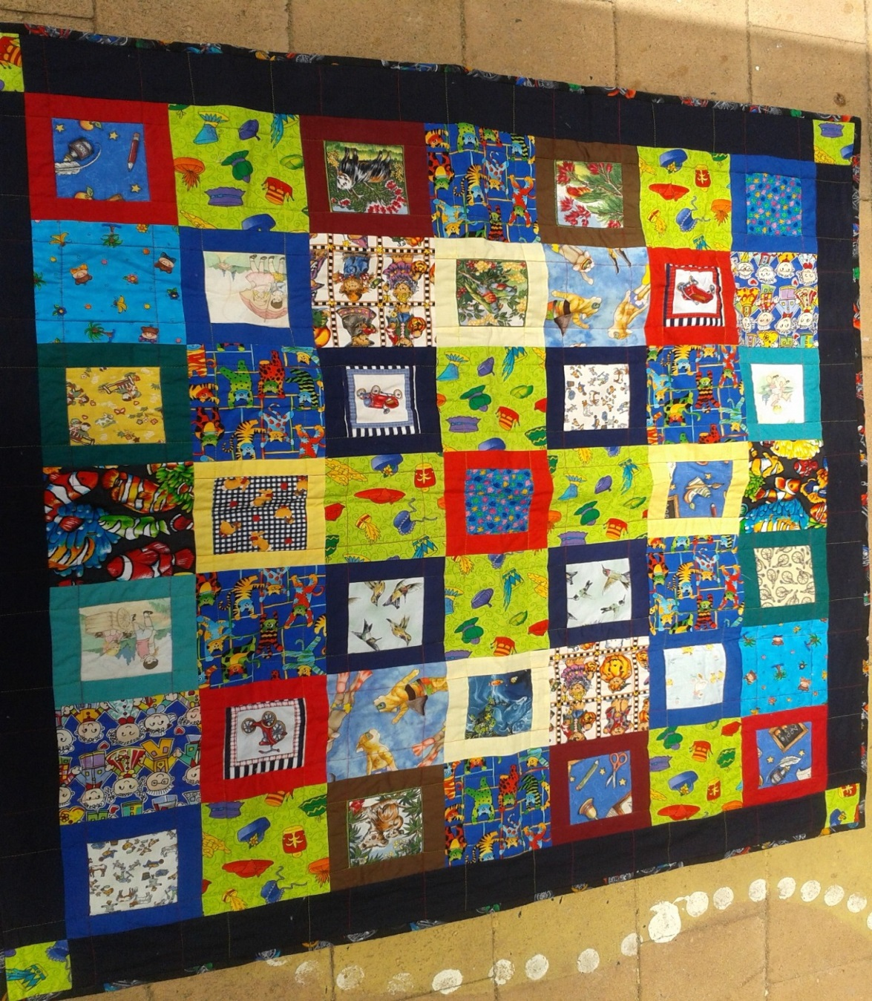

Beryl Women Inc.

**annual report 2013-14**

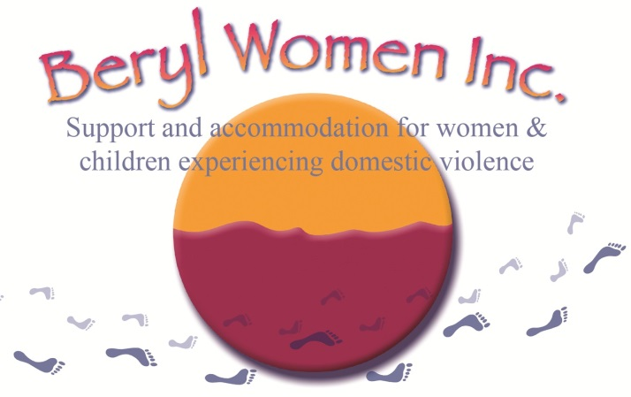

Beryl Women Inc.

Support and accommodation for women and children experiencing domestic violence

Office Hours

9-5pm, Monday to Friday

Office (02) 62306900

Fax (02) 62473511

Email [beryl_women@bigpond.com](mailto:beryl_women@bigpond.com)

Website [www.beryl.org](http://www.beryl.org)

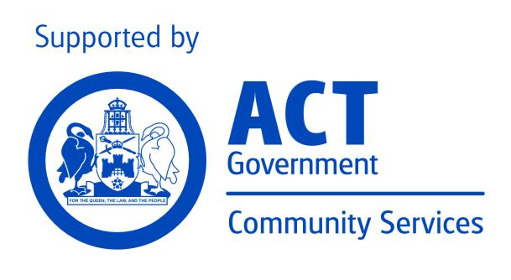

Mission

Beryl Women Inc. is committed to providing high quality support and safe accommodation to women and children escaping domestic/family violence. The organisation recognises that violence against women and children is prevalent in our society and that injustices such as sexism, racism, economic inequality and homophobia contribute to families living in crisis. To redress this, Beryl Women Inc. will provide a professional and accountable service that is based in social justice, recognising and fostering cultural diversity.

Organisational Aim

Beryl Women Inc. aims to contribute to the enhanced safety of the families who stay at Beryl, to their improved health outcomes, and to provide opportunities to increase their skills and confidence to manage future crisis.

Goals of Strategic Plan

July 2013 – June 2016

BERYL WOMEN INC. will be a sustainable organisation that provides high quality domestic violence-specific services to women and children

Through

The development of partnerships and collaboration with other community services and government agencies in order to be part of a holistic response to women and children escaping domestic violence

A strong identity and profile in the ACT community as a feminist organisation offering high quality services



A strong identity and profile in the ACT community as a service that is welcoming of, accessible to, and appropriately supportive of Aboriginal and Torres Strait Islander women and children and women and children from culturally and linguistically diverse backgrounds (CALD)

Being an organisation that encourages a learning culture and is innovative in its response to support women and children escaping domestic violence



Herstory

Originally named the Canberra Women’s Refuge, Beryl was established in a house in Watson in March 1975 with a grant of $4000 from the Department of the Capital Territory. Volunteers, who ran a 24-hour roster, seven days a week, staffed the first refuge. In 1976 the service moved to a duplex in Kingston and sometime later funding was received for employment of a skeleton staff.

In 1976 the service changed its name to Beryl Women’s Refuge, after Beryl Henderson who started the original trust fund for the refuge, which, outside of the $4000 Grant received from the government, was the sole means of supporting the cost of running the service. In 2005 the service changed its name again to Beryl Women Inc.

Beryl Henderson was an active member of the ACT Women’s Liberation Movement and the co-founder of the Abortion Law Reform Association in Canberra. She also worked for Family Planning and the Humanist Society. Beryl taught languages on an Israeli kibbutz in 1960 to 1964 before coming to Australia. She returned to Israel in the late 1970s and died there in her 94th year and will always be celebrated for her dedication and commitment to the cause of equality. Beryl Women Inc. is proud to carry Beryl Henderson’s name as a daily reminder that those wonderful ‘big sisters’ who came before us, made possible the services we have today.

Report from the chairperson

This has been another very challenging year for the staff at Beryl Women Inc. (Beryl) as they continue to support women and children escaping domestic and family violence.

There were a number of major changes during this year which has impacted on the organisation. Notably was the return of the office to the refuge site. Due to financial constraints this move was seen as significant way to reduce costs around rent, travel time, but there were some pluses to this move, clients now have easier access to workers due to the office now being on site.

One of the major issues that involved the management committee this year was the negotiating of staff entitlements to ensure they stayed in line with the budget. It is often difficult to maintain the entitlements for staff under tight budgetary constraints but it is important to ensure there is a good balance between staff being recognised and rewarded for the work they do and staying within the budget requirements. There were a number of discussions between the staff and the management committee. A new MEA schedule has been developed which ensures there is no disadvantage to workers.

Beryl Women Inc. continues to work closely in partnership with Toora Women Inc. and Canberra Rape Crisis Centre to deliver the Coming Home program which provides a range of services to support women leaving the prison system to prevent homelessness and recidivism.

As mentioned in previous reports Beryl is still discussing the feasibility and appropriateness for a possible merger and/or partnership with other women’s services that provide support to women and children escaping domestic and family violence. It is very important that Women’s Services position themselves to have a stronger voice to ensure the appropriateness of services for women and children escaping domestic violence particularly in the ACT. Discussions are planned with other services in the near future.

Even though Beryl’s 40th birthday is not until next March, preparations are well under way. Farzana Choudhury is in the process of putting together a book of the history of Beryl. She has organised to talk with current and previous clients and staff, including committee members. The book will be a wonderful historical tribute to Beryl.

This year has seen a number of committee members leave and a number of new members coming on board. It is not always easy to commit the time and energy to participating at the management level of any organisation. People often have other competing priorities so it is not unusual that committee members change throughout the year. Outgoing committee members included; Merilyn Banfield, Ara Creswell , Terri Francis. I would like to thank all the outgoing members for their commitment to Beryl during their time on the management committee.

This year we welcomed Bronwyn Smith to the committee, Bronwyn was a member several years ago and it is wonderful to have her back and sharing her knowledge and expertise with the organisation.

Once again I would like to thank all committee members for their work over the year and the staff at Beryl for the support they provide to women and children to access safe, appropriate and affordable housing. I would also like to thank Beryl’s Manager, Robyn Martin, for the leadership she has provided to both the staff and the Management Committee through this period and I look forward to working with her over the next twelve months.

Rhonda Woodward

Chairperson

Beryl Women Inc.

Governance Committee

**Chair Rhonda Woodward**

Deputy Chair Beth Sywulsky

Treasurer Lillian Lesueur

Members Farzana Choudhury

Marzieh Tafreshi

Bronwyn Smith

Paula McGrady

Bronwyn Smith

Resigned Terri Francis

Ara Cresswell

Merrilyn Banfield

Staff

**Manager Robyn Martin**

Book-keeper Mirtha Abello

Support Worker Linda Hayden

Support Worker Lina Louis

Admin Worker Jennifer Dunkley

Child & Youth Support Worker Angie Piubello

Casual Relief Sharon Williams

Casual Relief Sandra Hillard

Casual Relief Penny Pestano

Support Worker Coming Home Program Kitty Waddell (Resigned)

Casual Relief Charmaine Barrett (Resigned)

Casual Relief Sulainah Mbabazi (Resigned)

Casual Relief Yuyila Pullen (Resigned)

Report from the Manager

Beryl Women Inc. has experienced great change over the last year at all levels of the organisation, including Governance with changes to our committee, constitution and funding structure which has also affected changes to staffing and service delivery along with a move of offices for staff and management.

To some extent we have travelled full circle with the past years having the main office and staff working off site and this past year returning back to the refuge site. This was seen as no longer viable with the funding for the organisation being reduced in 2013/14 due to the NAHA Reforms which other homelessness women’s services were also impacted by.

Beryl Women Inc. has been in operation coming up to 40 years in 2015 and it seems a good time to reflect on where we have come from and where we may be headed in an ever changing political and sector environment. Being a part of the Homelessness System in the ACT and a woman’s service has meant that the service is not invulnerable to the changing political climate and the impact this has on funding to services that support vulnerable people in our society.

Over the years Beryl has ridden these waves of change with strength, flexibility, and grace. I believe the commitment and dedication to its aims and vision are what keeps the organisation sustainable through many highs and lows. To the many women over the years that have fought the good fight as feminists and ensured that this service continues to open its doors to women and children we are very grateful.

This last year has seen NSW refuges undergo great loss with Elsies the oldest women’s refuge in NSW closing its doors due to changes that the NSW government has implemented. With Beryl being the second oldest women’s refuge in the Country it is not an easy environment to be in when we see other sister organisations closing down and or losing their feminist focus. It is vitally important at this time to take action and advocate for the women and children that are not in the position to do so for them-selves.

With ever increasing statistics nationally and the ACT showing that domestic violence is increasing it is paramount that services such as Beryl Women Inc. continue to provide the type of specialised support that women and children who have experienced domestic and or family violence require. Domestic and family violence are complex issues with no one simple solution.

The action the Federal Government and ACT Government have taken to respond to these issues with the National Plan to reduce Violence against Women and The ACT Strategy for the prevention of Violence against Women and their Children is a step forward in the work that is needed in ending domestic violence in this country.

This past year Beryl Women Inc. has been a participant on the Sub-Committee to commence development of a 2nd Implementation Plan under the above Strategy.  The Beryl Manager has been specifically approached because of Beryl’s acknowledged commitment to and knowledge of the needs of Aboriginal & Torres Strait Islander women and children, as one of the objectives is Primary Objective 2 – *Aboriginal and Torres Strait Islander women and children are safe because an anti-violence culture exists in the ACT*. The Strategy was developed in the context of the ACT Government’s commitment to the National Plan. The National Plan also has an Action Plan to progress identified actions against its objectives. The ACT developed the Implementation Plan from 2011-2014 to do the same. The first Implementation Plan for the ACT is due to be finalised by the end of 2014. The development of a 2nd Implementation Plan is now being actioned.

Beryl Women Inc. is very proud of its culture and heritage and see its’ role in the present and the future as a strong feminist service working to ensure that the outcomes in both the National Plan and ACT Strategy are achieved.

Aboriginal Elected Body – Whole of Government Agreement

Robyn Martin as Manager attended a number of consultations being held in the community by the Aboriginal and Torres Strait Islander Elected Body who have been involved in the process of developing a Whole of Government Agreement with the ACT Government. The Agreement will cover the following:

Reconciliation Action Plan - The Statement of Commitment to Reconciliation will address key identified topics including: relationships/collaboration, respect/awareness and opportunities. It aims to achieve “line of sight” between the Statement of Commitment to Reconciliation and individual Reconciliation Action Plans.

1. provide a high level statement of commitment to reconciliation in the ACT;
2. commit all ACT Government Directorates to develop individual Reconciliation

Action Plans; and

1. provide guidance on key strategic elements Directorates could address in their

Reconciliation Action Plans.

ACT Protocols **-** The Agreement will set out how the ACT Government will embed a consistent governance process into Directorates that will support Aboriginal and Torres Strait Islander people and their communities to be involved in the design, development and implementation of policies, programs and services that are specific to their needs.

 The Agreement will also define how the ACT Government will consult with Aboriginal and Torres Strait Islander Peoples to improve how health, housing, economic and social services are delivered. It will provide a framework for relations between the Aboriginal and Torres Islander communities and the ACT Government by articulating the principles of good communication and partnership.



Acknowledgments

The experience, understanding and relationships that Beryl Women Inc. has been able to build within the ACT Community over the years has meant that we are greatly supported by other community, non for profit and government agencies. This support is also what helps to keep our organisation strong and positive through difficult times and reminds us that by working together, we are stronger as a community. I would like to mention a warm thankyou to our network supporters that have travelled alongside us these challenging times this past year. Your kindness and caring has been a source of strength to everyone involved in the service.

I would also like to specifically acknowledge the support of our funding body the Community Services Directorate and the Social Housing and Homelessness Services staff of the Community Services Directorate. Other partners we would like to acknowledge are DVCS, CRCS, Toora Women Inc. First Point Central Intake Service, Women’s Services, ACT Legal Aid, Women’s Legal Centre, Street Law, Centrelink Social Workers and Community Contact Officer, Office for Women, Northside Community Services and the many other services that directly or indirectly supported Beryl Women Inc. during the past financial year. We hope to continue to work in collaboration with you all in the coming year.

To the amazing and dedicated women of our Governance Committee and our Book-keeper this year who have guided the organisation through difficult times and ensured that we will continue to remain a viable and sustainable organisation. There have had to be some difficult decisions made during this period and you have donated your valuable time, knowledge and experience through-out this last year and your input and hard work have been greatly appreciated.

To the Staff Team and our Manager, the persistence and commitment that you show each day you come to work is so inspiring alongside the care and compassion that you give to the women and children of the service. Without your commitment we would not be able to provide the service that women and children deserve. Strong Team Work in the crisis environment is vital for worker wellbeing and sustaining staff, and all the staff in the service have shown we are a strong team that shows encouragement, support and commitment to each other and to the women and children we support. It has been a challenging and very busy year but we have achieved a lot because of the strong leadership of our Manager and our commitment as a service to feminist principles.

Finally and most importantly to the women and children that have been supported at Beryl Women Inc. this past year. We are always in awe of your courage, strength and bravery to step out of violence and into safety. We hope that your journey continues to be positive and your future dreams fulfilled.

Angie Piubello

Acting Manager

Service Management

The service has been through a process of change management this past year with this the first year with reduced funding. Decisions were needed to be made regarding our On Call (after hours) support and policy and procedures.

The Staff Team were involved with the support of the Committee and it was clearly understood that it was a necessary and important provision to the holistic and flexible support that Beryl provides. Clients in the service come with complex needs specifically around safety, children and wellbeing. To ensure our service continue to prioritise these areas the On Call was seen as a vital part of our service delivery.

Workers have also made changes to conditions and the service has developed a new MEA schedule with support of the ASU to ensure that changes are not disadvantaging workers.

The change process has also enabled clients to have easier access to workers due to the office now being onsite. This has also been of benefit to staff as there is less time required for travelling to and from clients and issues within the refuge setting are managed within an earlier timeframe therefore lessening the risk of more serious crisis from occurring.

We have had one 3 bedroom property off line for 6 weeks due to repairs and recarpeting being done by ACT Housing. All 7 properties are rented from ACT Housing at a reduced market rate and 5 of the seven are approx. 30-40 years old. Maintenance, wear and tear and aging of properties that have numerous families residing in them over a 12 month period require extensive and ongoing work and maintenance.

The service is looking to acquire additional funding for tenancy management in the future to ensure properties internally and externally are kept to standards required by law and the funding body. Tenancy Management requires a high level of resources both in time and labour. Such requirements as end of lease cleans and regular house inspections are an extra load on service delivery and workers that are already managing a high and complex case load including outreach. Support workers are responsible for property management additional to case management which can impact negatively on workloads especially at times of families entering and exiting properties.

Funding towards furnishings, outdoor equipment and general household electrical items are always a cost to the service as families need to enter a home with all the house hold items available and in a good working order. Donations from the community such as white goods, furniture and electrical items are of great assistance and make a difference in the area of property management.

From a funding perspective the service has been researching alternative and additional areas for funding. The service has been fortunate to have had an offer of consulting services from the ANU to provide consultation on the future service development in the following key areas: social media, marketing, funding, grants, donations and sponsorships. We look forward to the outcomes of this process and hope to commence the implementing of some new initiatives in the next 12-18 months to raise additional funds to meet the needs of the service in the short and longer term. We would like to thank the women from 180 Degrees Consulting for their donation of time and resources and look forward to an ongoing relationship in the future.

The Staff Planning Day was a very productive exercise with Staff and Management strongly supporting the continuation of our focus from the Strategic Plan on increasing access for Aboriginal and Torres Strait Islander Women and children.

The service practices to ensure that it is culturally sensitive for Aboriginal Women and Children and identifies the trans- generational trauma that these families have undergone. In the changing environment of the sector Beryl Women Inc. aims to ensure that these families experience a sense of safety to engage with the service and does this through a number of ways. Beryl Works collaboratively with other Aboriginal and Torres Strait Islander specific services and employs 2 Aboriginal Staff Members.

Beryl also has a strong commitment to reconciliation and awareness raising of Aboriginal culture, practices and issues with staff regularly engaged with clients in culturally specific activities such as NAIDOC Week Celebrations and the Sorry Day Bridge Walk and this past year clients and workers together participated in a cleansing Ceremony with Ngunnawal Elder Auntie Janet as a welcoming back to the refuge site. We would like to thank and acknowledge Auntie Janet for her special visit which provided a space for non-aboriginal women to experience and learn more about the cultural practices of the Aboriginal community in the ACT.

Beryl 40th Birthday

Beryl will be celebrating its 40th Birthday in 2015 and has decided that it would be an ideal time for the service to gather up all the important history from the previous 40 years with a Beryl History Book to acknowledge the journey of the service and work that has been given to support women and children escaping domestic violence.

The Book project commenced in June 2014 and is currently underway with the support and many hours of work from women in the ACT Community that have donated their time, and expertise to the project.

These women all come with a passion and commitment to feminism. I would especially like to acknowledge and express our gratitude to all the Committee Members of Beryl Women Inc. that have ensured that this project has been possible and we look forward to the celebrations and launch next year.

The Alliance – Coming Home Program

The Alliance between Canberra Rape Crisis Centre, Toora Women Inc. and Beryl Women Inc. grows stronger as each year progresses. In the last year the above services have been faced with challenges due to funding changes and restructuring but have maintained their commitment to the Alliance.

While the Program has undergone staffing changes throughout the year the Beryl Support Worker position has continued to be filled. The program is achieving great outcomes for Women in the ACT that are exiting prison and provides essential support from within the AMC and in the community. The program provides a wraparound approach for clients through working collaboratively with stakeholders such as Community Justice, Drug and Alcohol Services and Women’s support services. Alongside accommodation clients are provided with a skilled support worker that works with the women to assist them to achieve positive outcomes and reduce rates of recidivism.

The Alliance regularly meets to ensure that the program provides a high quality of service to the women and children that it supports.

I would like to acknowledge the commitment of the Management and staff of the Canberra Rape Crisis Centre and Toora Women Inc. during a period of change ensuring that women exiting prison are given the opportunity to improve their lives and achieve their personal goals.

Domestic Violence Christmas Crisis Program

This program commenced on the 16 December 2013 and ended on the 27 January, 2014. The program is funded by the Community Services Directorate with a small number of services from the Community Services Directorate working in partnership.

Services involved in the program are St Vincent DePaul, Inanna Inc., Doris Women’s Refuge and the Domestic Violence Crisis Service. Motel accommodation is provided for women and children escaping domestic violence during the Christmas/Holiday period and services provide outreach support to families that are temporarily accommodated and assist families to find more stable accommodation as needed.

During this program, we accommodated 4 women with 6 children all escaping domestic/family violence. All families were referred to Beryl Women Inc. by DVCS.

Support to these women included the following which was delivered within a case management framework.

* Accommodation
* Emotional support
* Domestic Violence Support
* Financial support
* Material aide
* Planning & referral to other community support services
* Advocacy and Liaison on behalf of client
* Access to Beryl Women Inc. Programs
* Interpreters
* Court Support and DVO Orders

Clients were provided with a number of material items including food as well as Xmas Hampers. We also provided phone cards, bus tickets, taxi vouchers and had purchased a mobile phone (with credit) for those clients that didn’t have a mobile phone.

Outcomes:

1 Woman and 3 children offered accommodation at Beryl.

1 Woman with 2 accommodated within Beryl

1 Woman returned home with DVO and kick-out order for perpetrator removal

1 Woman with 1 child returned home

Donations

Beryl Women Inc. have built strong relationships in the community and are very grateful to all the individuals and businesses that have provided financial support and support in the way of whitegoods, furniture items, handmade blankets and general household and food items. The website enables the community to have a greater understanding of what our needs are and the ACT Community and individuals from interstate have been extremely supportive of the service this past year. I would like to formally acknowledge and express our thanks particularly to the following;

* Attorney Generals Department for their kind donations through their Workplace Giving Program and food and cleaning packs for women
* Hands across Canberra, for their ongoing support through their community giving portal. With their support we are able to provide emergency food and safety packs and school stationery for children and young people.
* Organisers from the Fruit Tingles Dance Event who have also generously provided funds to the service.
* Eternity Church for their ongoing support and encouragement
* Labour Women for their financial support and donations of hand knitted blankets
* Masters- building materials
* Bunnings Fyshwick- building materials
* DPO Gyprocking – Labour
* Workplace Giving- Aust. Blood Authority

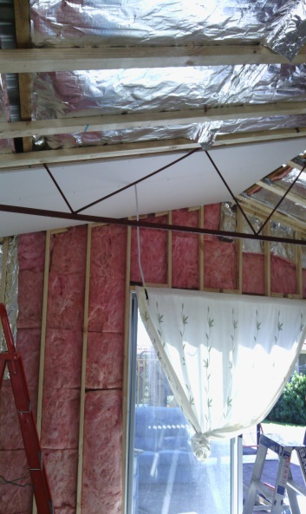 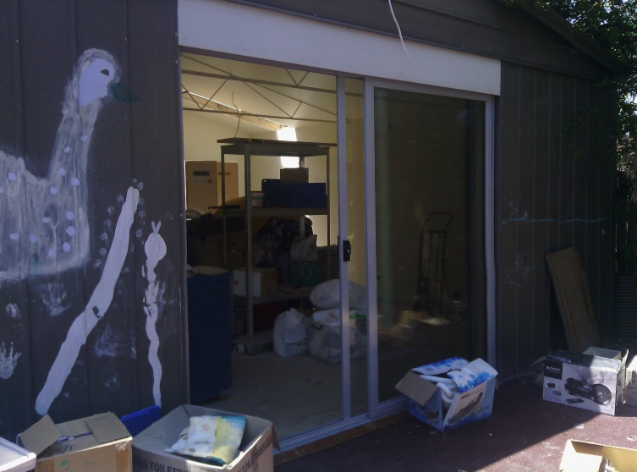

Shed Donation Stage 1 Shed Donation Stage 3

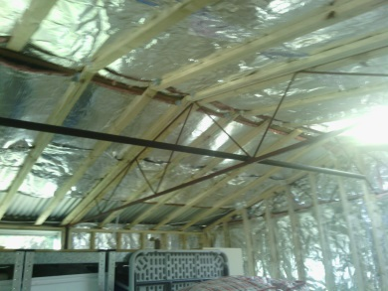 Shed Donation Stage 2

Grants

Due to the changes to the funding structure within Beryl the importance of seeking assistance through specific Grant providers is a high priority.

Staff and management are all engaged in the sourcing and writing of grant applications and involved in implementation of the projects that the grants are required for.

This financial year we have focused on applying for grants for a number of projects and have been successful with two. Funds are to be received and expended in the following financial year. The two successful grants applied for were through Hands across Canberra for Domestic Violence Start up Packs and the Commonwealth Bank for School Holiday

program activities for the Children’s Program.

Both grants will ensure that we can continue to provide direct support to families when first entering the refuge and fulfilling basic needs such as food, health and safety, and give vulnerable children opportunities to engage with community and have their social, mental and emotional needs met.

Confiscation of Criminal Assets Trust Fund grants Program

This financial year we have expended funds to the value of $10,000 received through the Confiscation of Criminal Assets Trust Fund grants Program for the “Safe at Home” camera surveillance project. The funds went to a security upgrade on our office and 4 properties with security cameras installed for additional safety for staff and clients. The feedback from clients has been very positive as the presence of surveillance has given the women and children an increased sense of safety as a deterrent to perpetrators and as a source of physical evidence that can be used if necessary in legal proceedings.

Training

We are committed to the ongoing training and development of our workforce, aimed at the provision of high quality services for our client group. In keeping with this commitment we have provided staff with a range of training options, detailed below, to enhance and build on their current skills.

* Getting your Employment Practices Right
* IT & Communications Seminar
* NDIS readiness Toolkit Workshop
* Industrial Relations issues
* Working with indigenous Families at Risk- Judy Atkinson
* Effective Grant Writing for Emerging Leaders
* Women and Justice Forum- Women and the Workplace
* What’s Up with My Mob
* Mental Health First Aid specific to Aboriginal & Torres Strait Islander peoples;
* Managing through Change;
* Audrey Fagan Financial Forum;
* Analysing the Financial Health of a NFP Organisation;
* Governance & Financial Management Initiative Showcase;
* Outcomes Workshop x 2
* Trauma and Kids Protective factors and treatment- Mental Health Professional Network
* Working with Infants and their Caregivers Therapeutic Responses and Research- Aus. Assoc. for Infant Mental Health.
* International Symposium on Children and Communities in Australia

Collaborative Working Relationships in the Community

Beryl has been involved in a number of consultations within the ACT community. These ensure that the service is up to date with changes within the sector and importantly continues to maintain strong positive working relationships with Government and Community Services on issues related to Domestic/Family violence, Aboriginal and Torres Strait Islander Women and children and Women from a Refugee Background.

The Manager attended and spoke at the 2013 ACT Roundtable for the Prevention of violence against women and children which was being hosted by ACT Policing. Topics for inclusion in the paper were current successful approaches and strategies in prevention of violence in Aboriginal and Torres Strait Islander and Culturally and Linguistically Diverse Background communities and challenges that exist in preventing violence in Aboriginal and Torres Strait Islander communities and Culturally Linguistically Diverse Background communities.

The service also participated in a research project titled From Caring to Cultural with the Domestic Violence Crisis Service. The aim of the project was to inform best practice and culturally informed service delivery for DVCS to Aboriginal & Torres Strait Islander people affected by family violence in the ACT.

Alongside the Round Table for the Prevention of Violence Against women and children, the Manger attended a high tea at the Hyatt with the ACT Aboriginal and Torres Strait Islander Elected Body. The afternoon tea was to bring together women in government, non-government and the community to discuss issues of concern and to raise those with members of the elected body.

The service also attended a range of other meetings, consultations, steering groups, launches, rallies and events of significance to our organisation.

Some of these were:

* Governance Group – 2nd Implementation Plan on the ACT Prevention of Violence Against Women and Children Strategy 2011-17
* Sub-Committee – to develop the 2nd Implementation Plan for the ACT Prevention of Violence Against Women and Children Strategy
* Women’s Health Service – My Past My Present My Future Program
* Ministerial Advisory Council of Women (MACW)
* World Health Day afternoon Tea at American Embassy
* Return to Work Review (MACW)
* Sorry Day Bridge Walk
* Aboriginal Torres Strait Islander Elected body (ATSIEB) Community Forums
* Coming Home Alliance
* Joint Pathways
* Women’s Services Network
* ACT Shelter
* International Women’s Day Breakfast
* DVCS Candle lighting Ceremony
* Refugee Week event at Parliament House
* First Point Advisory Group
* DV Alert Multicultural Training Development Project (Lifeline)
* Hands Across Canberra Luncheon
* Country Women’s Association: Attended presentation followed by donation for clients
* Zonta Club: Attended presentation to give info about Beryl and Sector issues for women
* Melba College Presentation to Students about Community Sector Work and Domestic Violence Services
* NDIS Symposium at Hellenic Club

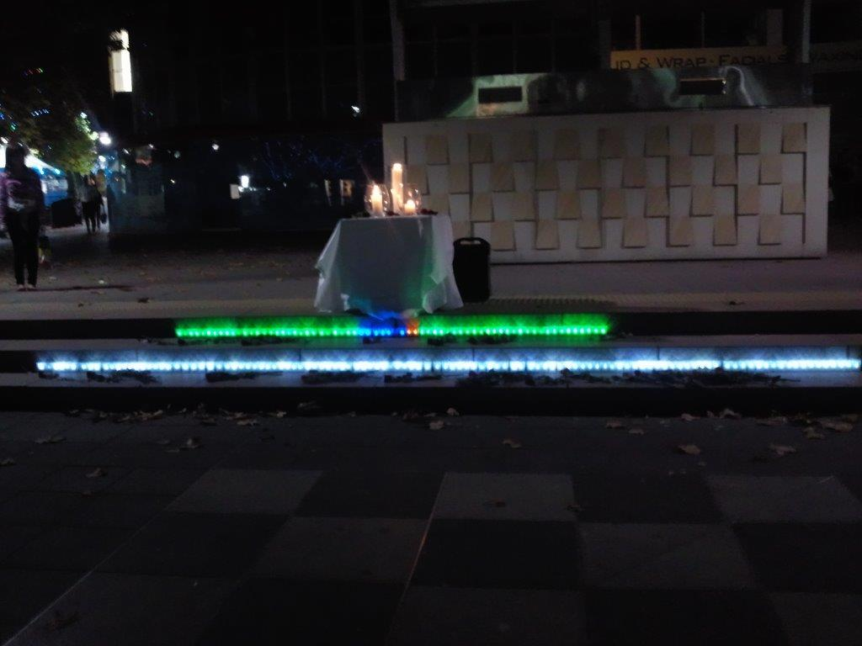

DVCS Candle Lighting Ceremony

Media and raising Community Awareness

Beryl has been a participant on a new Domestic Violence Media Initiative.

The *Guides for ACT Media - Reporting on Violence against Women and Children in the ACT* were developed in response to a need for media to have clear guidelines when reporting on Domestic and Sexual Violence. Women’s Centre for Health Matters invited Beryl Women Inc. to participate in development of the Guide alongside Canberra Rape Crisis Centre and the Domestic Violence Crisis service.

The project was funded by the ACT Government Participation Women’s Grants. The guides were developed in consultation with local journalists and media/journalism students as a resource for those in the ACT media who have any involvement with the reporting of domestic violence, sexual violence, child sexual assault and Indigenous family violence.

They ensure that when media are reporting on the issues of Domestic Violence, Sexual Violence and Family violence there is a greater understanding of the complexities and underlying concerns related to these issues. Media play a vital role in awareness raising and information to the community around these issues and the Guides provide factual information to better support media when reporting.

Beryl Women Inc. has been involved in a number of awareness raising activities through media and some of those are listed below;

* Centrelink Media with Human Services Department - interviewed at Beryl with Community Engagement officer re community engagement and Beryl’s relationship with info re Domestic violence
* 2CC Radio interview re Domestic Violence and how women can get help. This came from Centrelink Human Services contact.
* SBS: Interviews re Women from refugee Background accessing Refuge Accommodation. Clients and staffed interviewed.
* Attended the White Ribbon Day National Press Club event with Guest Speaker, Chair of the Foundation to Prevent Violence against Women and their Children Natasha Stott Despoja who was also joined by Chief Commissioner of Victoria Police Ken Lay. The National Press Club kindly donated tickets for all staff to attend the luncheon.
* Invitation to speak at an International Women’s Day Event to the Australian Education Union ACT Branch about the impacts of Domestic Violence on women and children and how to identify and respond within the school setting to children that are or have been living with violence.

V Day 1 Billion Rising Activities

V Day 1 Billion Rising is an important day of Activism On Feb 14 for women and girls to speak up and bring awareness to issues of violence against women and girls. It is an International Day of activism with the ACT this year becoming more active in V Day activities.

Beryl Women Inc. were involved this year in two events. The Manager was asked to speak at the Public Panel Discussion “Violence against Women” Solutions for the Future. The event was hosted by the ANU- Human resources with a number of prominent guest speakers from Domestic Violence and Sexual Assault Services, The ACT Supreme Court and ACT Policing.

The service also linked with local theatre producers to present a benefit reading of A Memory, A Monologue, A Rant and a Prayer at Commonwealth Park.

The V Day event involved local ACT women and men to act out certain monologues and stories from women and girls that had experienced violence in their lives. Stories were shared from women and girls from varied backgrounds and nationalities. The event was the first to be held in the ACT of its kind and we hope to be able to have the event grow in numbers next year. The event was free with donations received going to DVCS.



Community Linkages

Links to services and advocacy on behalf of clients have been in relation to specific

support needs:

* Employment
* Training Courses/Women’s Information Referral Centre
* Tertiary Education Support
* Community Food Banks
* Financial Counselling Services
* Legal Aid/ Street Law
* Centrelink Social Work Team and Community Engagement Team
* Women’s legal service
* Translation and Interpreting Service (TIS)
* Migrant Refugee Services
* Women’s Health Practitioners
* Crisis Mental health Services/Trauma and Psychological Services
* Victims Support services
* Pregnancy support
* Midwifery Support
* Mach Nurse
* Childcare Providers
* Child at Risk Health Unit
* Child Specific Developmental Needs
* Therapy ACT/Early Intervention Education
* Dental Health
* Belconnen Community Services
* Smith Family
* Salvation Army
* Gungahlin Child and Family Centre
* OYCFS
* ACT Education and Training Directorate

Client Functions

* A number of events have been held during the year involving client participation, following are just some:
* NAIDOC Day BBQ – Celebration and Sharing of Aboriginal and Torres Strait Islander culture
* Cleansing Ceremony at Beryl Refuge
* Harmony Day Luncheon – Celebration and sharing of Multiculturalism
* Seasonal Trash n Treasure Days - provision of donated goods such as household items, personal items and children’s toys and books.
* Mother’s Day – Mother’s Day Luncheon
* Christmas Celebration – Client Xmas Party

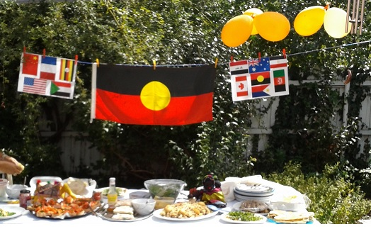

Women’s Groups

Beryl has a strong focus on creating a therapeutic environment that encourages a sense of community and connectedness for women and children.

Regular women’s groups are provided to support women in building connections within their community and sharing stories that empower and provide emotional support and strength to families.

Groups encourage self-development, education, increased social skills, confidence building, healthy self-esteem and positive relationships. Services regularly attend the Groups to provide women with relevant and current information that they may find helpful to their situation. We have found this to be very successful with women feeling connected to the service provider and much more likely to access the service provider once they have made that connection at the women’s group.

To demonstrate the benefits of this Beryl Women Inc. have had a greater number of women access the Return to Work Grant program after their service visit to the Women’s Group. This has enabled women to start to look at longer term options around studying and work and has proved a positive factor in women’s wellbeing and independence and self-esteem. The service was also involved in the review of the Return to Work Grants as a member of the ACT Ministerial Advisory Council of Women (MACW). The current practice in supporting women accessing these grants in terms of employment and further education has been identified as a useful model for further outreach service delivery in the community. This partnership has resulted in several women successfully accessing the program which has then increased their employability and confidence and self- esteem.

Services that have attended our Women’s Group this past 12 months.

* Care Financial- Money Management
* Street Law
* Women's Health
* Centrelink Social Work Team
* Sexual Health
* Hepatitis ACT
* Women’s Legal Centre
* 6 Weeks Hairdressing and Self-Care Day
* Bossum Buddies – Education around women’s health and breast care
* Migrant and Refugee Settlement Services MARS

Feed-Back from Women’s Group

*• “found this very helpful and supportive, great women support, good info and want to still come after leaving the refuge”*

*• “today was good, because conversation showed me it’s better to be with*

*your- self than your partner. If I try to satisfy everybody, I will lose my happiness!*

*I realised I can reflect my feelings I don’t have to keep it to make everything*

*Better… thank you for awakening me”*

*• “it was good today because I can name things that we have gone through. and the important things also was what to base a new relationship on in the future”*

*• “even when I see you busy working and running around, you make time to listen and chat, you show you care, you want to help. If it wasn’t for this place, I don’t know where I would be. You help us find our voice. Since I’ve been here, I’ve learnt so much about myself and what I can co and that I’m strong. Even when I’m low, if you women show up it brings some brightness to my day. You’ve been so supportive and since leaving QLD and being on my own it’s been great to know you guys are there for me”*

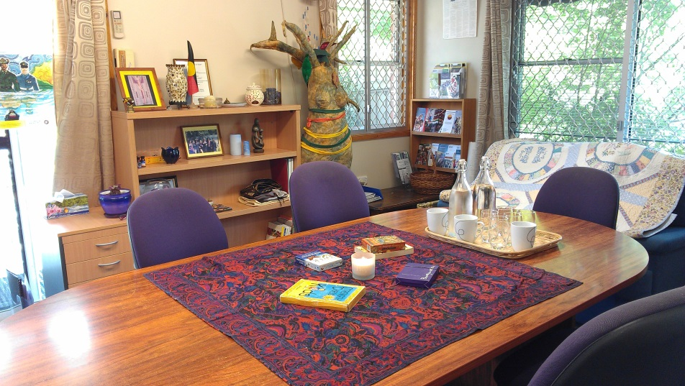

Women’s Group Space

Outreach Support

Outreach support to clients during this reporting period has increased. A number of these families are ex-clients receiving ongoing support from the service for a short period of time whilst they are transitioning into their new home and community. Outreach support to this client group has centred on connecting to community and services within the area.

Beryl is also providing outreach support to women referred either through First Point, self- referral or through another organisation, the number of these referrals has increased.

Outreach support has centred around domestic violence support, court support and housing support, with applications and transfers of government housing due to perpetrators knowing address of properties, and not adhering to Domestic Violence Orders or women fleeing family/neighbourhood violence.

Child/Youth Support Program

The Child and Youth Support Program has been busy than ever with numbers of children always greater than mothers.

A major project currently underway for the children of the service this year has been the refurbishing of our double garage into a bright new therapeutic play space for children and women’s workshops.

The garage sits beside the outdoor playground area, and is accessible to all clients visiting the refuge and the children residing in the share houses.

We are very grateful and excited to have received funds from the Snow Foundation towards the refurbishment costs and have been steadily moving along with the project and hope to have a completion in December 2014, just in time for summer school holidays and the Xmas break.

We have also had numerous donations of labour from small businesses and individuals in the Community and we would like to acknowledge and thank their donation of time and materials to the project.

Due to this project and limited space available for groups the service groups have been limited to an outside weekly playgroup for younger children and external 1:1 case management with families and home visiting.

Our school holiday program has been ongoing with financial support offered to families for activities and regular outings to the National Museum school holiday program, thanks to the relationships that have been formed with Museum staff and the refuge. This has been a great experience with mums and children enjoying fun learning experiences together.

This year has seen intensive case management for some larger families and families with complex needs and experiencing trans-generational trauma. Families that have moved from interstate due to safety concerns in their previous state also have high and at times complex needs with no social supports in the ACT.

Parenting post domestic violence with a large family can be stressful and challenging, especially when dealing with family court issues. Support workers provide emotional support, referrals, advocacy and education and information around a number of issues impacting on mums and kids living in the refuge such as loss and grief, safety planning, self- esteem, independence, interpersonal relationships, schooling and mental health and wellbeing.

Children’s Play area at Refuge Community Space

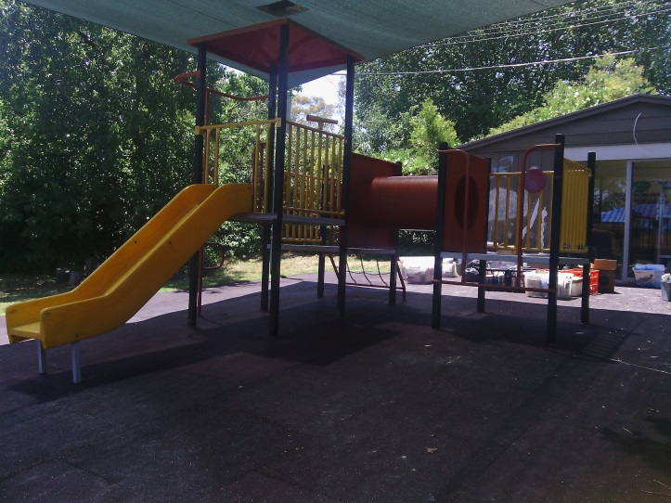

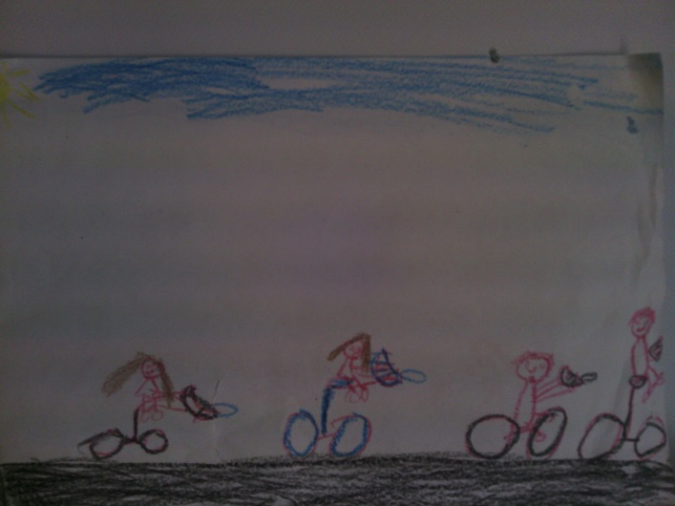

Child’s drawing of a Holiday Program Outing Bike ride

Service Demographics

Number of clients

In this financial year we supported 141 clients with accommodation and or preventative and maintenance outreach support. This included 51 presenting Units which consisted of 49 women with children, 1 twenty one year old woman and 1 fourteen year old girl.

Beryl Women Inc. provided crisis and medium term accommodation to 115 clients consisting of 42 women and 73 children. This included 1 family with a grandmother accompanying mother and daughter.

This accommodation was provided to 41 presenting units with 42 stays of accommodation.

We provided 9 women with 16 accompanying children and 1 fourteen year old with Outreach preventive support who have not been accommodated at Beryl during this period. Some of these clients had been ex clients from the past and others had not received support from Beryl until this period.

This year we supported 23 clients (16.3% of 141) for which there last permanent address had been interstate.

In many of these cases clients have been advised and provided support from interstate police to relocate out of their home state due to ongoing stalking or high risks of harm to women and children. For these families their trauma may be quite extensive due to a number of factors such as ongoing movement and instability of housing due to breaches to Domestic Violence orders by perpetrators, a lack of continuity of care due to fragmentation of service provision, and inappropriate or unsafe service responses due to insufficient funding.

Schooling may be severely interrupted for children numerous times throughout a year and moving to a whole new area places families at a great disadvantage in accessing supports. Providing a high level of support is necessary for these families to re-settle and recover from the impacts of trauma and violence.

Women from a culturally and Linguistically Diverse Background also tend to stay for much longer periods, have limited English and can have complex visa and immigration issues. This has the effect of short term refuge space being unavailable for other groups of women that tend to stay for shorter periods such as women from an Aboriginal and Torres Strait Islander Background.

Cultural Breakdown

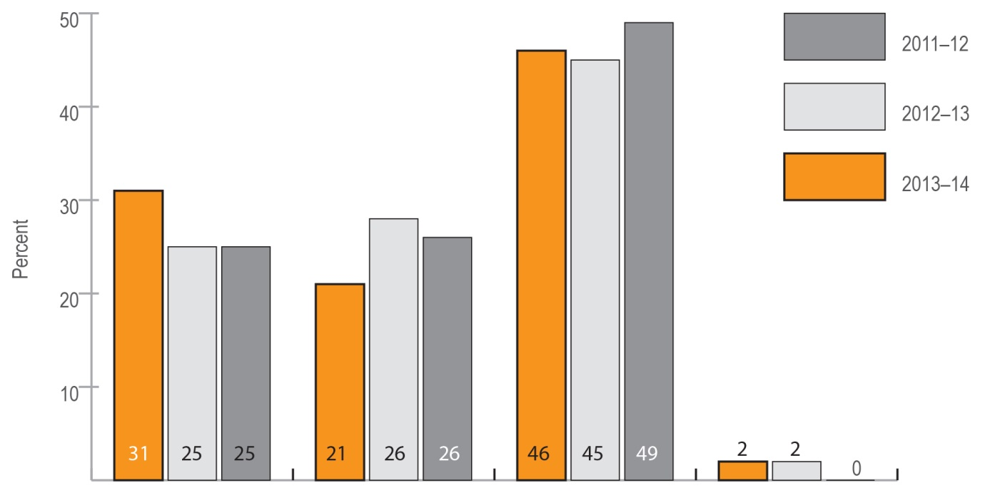CALD 31% (45) Koori 21% (29) Anglo 46% (67)

English speaking not born in Australia 2 % (3).

Overall this year there has been a significant increase in Cald families access support. A very interesting stat for this financial year is that 23 clients ( 16.3% of all clients) were born over seas. This included 18 women and 5 children.

Breakdown of women and children

Accompanying children make up the largest percent of clients accessing the service as shown in the following graph. These children having been directly or indirectly affected by the impacts of domestic/family violence suddenly find themselves in a refuge, disconnected from friends, family and social networks, often having to start a new school and may arrive with few personal belonging. All of these issues can contribute to many of the children experiencing significant loss and grief.

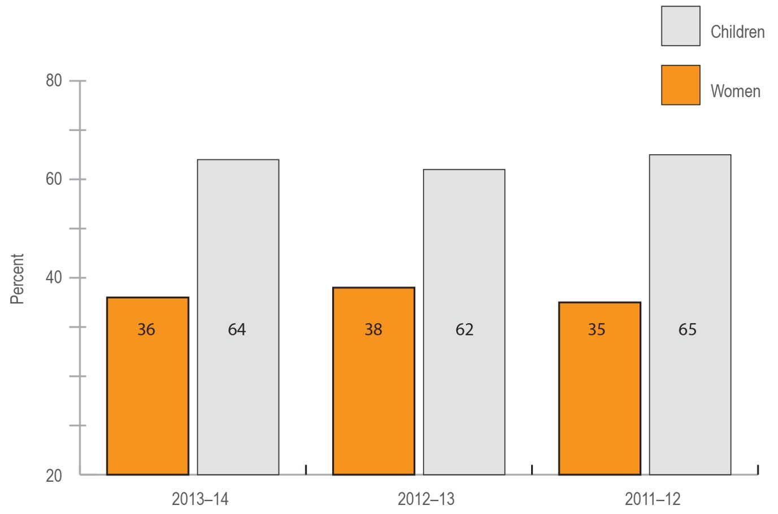

51 women (36% 0f 141) and 90 children (64% of 141). Women include 1 grandmother staying with mother and grand daughter. Some interesting stats for this year are 57 children (63% of 90) were 5 years or under. 15 women (29% of 51) were 36 years or older. 12 women (23.5% of 51) were 25 years or under.

Support Days

This graph show the amount of days of support provided to each client.

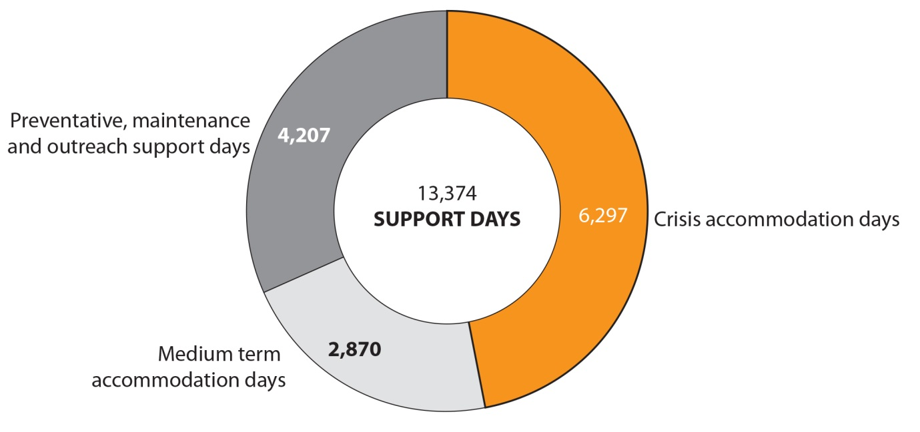

Overall Beryl Women Inc. provided 13374 days of support which includes 6297 days in crisis accommodation, 2870 days in medium term accomodation and 4207 days of preventive, mantaince and outreach support.

Preventive, maintaince and outreach support is available to all clients who have been accommodated at Beryl and move on to independent accommodation for a period of around 3 months if required.