Annual Report
Beryl Women Inc.

2009/10

MISSION STATEMENT 3
HISTORY 3
ORGANISATIONAL AIMS 3
WOMEN ASSOCIATED WITH BERYL WOMEN INC. DURING 2009/10 4
REPORT FROM BERYL WOMEN INC. CHAIRPERSON 5
REPORT FROM THE MANAGER 7
Employment and Staffing
Training
Data Collection
Collaborative Working relationships in the Community
Acknowledgments
SERVICE DELIVERY 11
Issues
Housing ACT
Outreach Support
Child Support Program
Community Events
SERVICE DEMOGRAPHICS 15
Number of Clients
Cultural Background
Source of referrals
Destination after exiting from the service
Number of Accommodation days
AUDITORS REPORT 20

MISSION STATEMENT

MISSION STATEMENT
Beryl Women Inc. is committed to providing high quality support and safe accommodation to women and children escaping domestic/family violence. The organisation recognises that violence against women and children is prevalent in our society and that injustices such as sexism, racism, economic inequality and homophobia contribute to families living in crisis. To redress this, Beryl Women Inc. will provide a professional and accountable service that is based in social justice, recognising and fostering cultural diversity.

HISTORY

Originally named the Canberra Women’s Refuge, Beryl was established in a house in Watson in March 1975 with a grant of $4000 from the Department of the Capital Territory. Volunteers, who ran a 24-hour roster, seven days a week, staffed the first refuge. In 1976 the service moved to a duplex in Kingston and some time later funding was received for employment of a skeleton staff.

In 1976 the service changed its name to Beryl Women’s Refuge, after Beryl Henderson who started the original trust fund for the refuge, which, outside of the $4000 Grant received from the government, was the sole means of supporting the cost of running the service. In 2005 the service changed its name again to Beryl Women Inc.

Beryl Henderson was an active member of the ACT Women’s Liberation Movement and the co-founder of the Abortion Law Reform Association in Canberra. She also worked for Family Planning and the Humanist Society. Beryl taught languages on an Israeli kibbutz in 1960 to 1964 before coming to Australia. She returned to Israel in the late 1970s and died there in her 94th year and will always be celebrated for her dedication and commitment to the cause of equality. Beryl Women Inc. is proud to carry Beryl Henderson’s name as a daily reminder that those wonderful ‘big sisters’ who came before us, made possible the services we have today.

At the 2006/07 Annual General Meeting the organisation ratified a name change from Beryl Women’s Refuge to Beryl Women Inc.

ORGANISATIONAL AIMS

Beryl Women Inc. aim to contribute to the enhanced safety of the families who stay at Beryl, to their improved health outcomes, and to provide opportunities to increase their skills and confidence to manage future crisis.

WOMEN ASSOCIATED WITH BERYL WOMEN INC. DURING 2009/10

Beryl Women Inc. would like to acknowledge and thank the women who contributed to achieving its vision in 2009/10.

They are:

Committee Members
Bronwyn Smith
Paula McGrady
Lindee Russell (Chairperson)
Brook McKail (Treasure)
Sarah Watt (Vice Chairperson)
Marie Coleman
Kiri Dicker (resigned)
Tessa Walsh (resigned)
Jane Shelling
Marina Germolus (resigned)
Brianna Jennings (resigned)
Rhonda Woodward (resigned)
Sue Ham (resigned)
Rosemary Windhaus (resigned)

Beryl Staff
Robyn Martin (Manager)
Mavis Rangiihu-Uhr
Alana McInerney
Helen Krig
Angie Piubello
Yasmin Paterson
Tracey Dewar
Tanya Talbot

Relief Staff
Linda Hayden
Sandra Hillard
Jane Mapiva
Lina Louis
Sage Nelly-Uhr

Bookkeeper
Mirtha Abello

REPORT FROM BERYL WOMEN INC. CHAIRPERSON

It is with great pleasure that I write this report as the Chairperson of Beryl Women Inc. I joined the Management Committee in 2009 and was elected as the Chairperson in early 2010. I felt honoured to be elected as Chairperson and undertook the role knowing the importance of a supportive Management Committee in the continuing operation and growth at Beryl.
Another busy and productive year passes at Beryl Women Inc. Some of the key highlights included:
- Changes to the Constitution occurred at a special meeting in March 2010 to allow for the appointment of two new office bearers; a Deputy Chairperson and a Treasurer as well as the inclusion of Associate Members. These new roles and associations were created in order to develop networks and opportunities for Beryl Women Inc. and strengthen the Committee.
- A successful and informative planning day was held with the Committee and Staff in June 2010 to review the Strategic Plan 2008-11 to ensure that Beryl Women Inc. continues to move forward despite the challenges they continually face. Outcomes from the day included a greater understanding between staff and committee members of each other’s roles and the part they play in it; recognition of what had been achieved since the inception of the Plan in 2008 and future directions were identified of where Beryl is heading. Some key areas identified for the coming year included:
  - We will develop and implement a RAP in 2011
  - We will explore the development an educative role in the community, particularly for teachers to improve the response to children who have been affected by family and domestic violence
  - We will focus on the profile of Beryl Women Inc. in order to increase understanding of domestic and family violence and the needs of the women and children who experience it.
- Throughout the year, the Committee identified the need for the creation of some key sub-committees (working groups) to allow for a more focussed and proficient approach to address and identify some of the issues being faced by Beryl and areas for development. These working groups then report back to the committee for discussion and further development. Some of the key working groups created include: Finance; Governance, Policy and Procedures, and Employment.
During this year the Management Committee has seen many changes. Leaving the Committee this year were Rhonda Woodward, Tessa Walsh, Kiri Dicker, Rosemary Windhaus, Merina Germolus, Brianna Jennings and Sue Ham. We would like to thank them for their invaluable contributions toward the management of the organisation.
We are very pleased to welcome to the Management Committee Sarah Watt, Jane Shelling, Brooke McKail, Jessica Reidy and Karen Campbell as new members. The Management Committee plays a vital role in the running of the organisation and the Committee is enthusiastic about the prospects ahead for Beryl Women Inc. and providing support to the refuge in the challenging but necessary role it plays in the Canberra community.
The Management Committee would especially like to thank all staff at Beryl Women Inc. for their dedication, professionalism and compassion they display every day in their vital support roles and acknowledges Robyn Martin for the leadership she provides to Beryl Women Inc. in her role as manager.

Lindee Russel
Chairperson
Beryl Women Inc.

REPORT FROM THE MANAGER

Beryl Women Inc. is one of the oldest women’s refuges in Canberra; we have been in operation for 35 years. We manage 7 properties that accommodate 8 families (2 of which are shared accommodation) for women with accompanying children who are escaping domestic/family violence.

2009/10 has seen many changes at Beryl Women Inc. This year we celebrated 35years of service to the Canberra community.

During this financial year, I participated in a week long summit developed and hosted by Oxfam Australia, called “Straight Talk”. The purpose of the program is to help bring about positive changes for the future for Aboriginal & Torres Strait Islander women, Australia wide. The program aims to provide opportunities to build lasting relationships with women in Federal Parliament; raise the profile of issues confronting Aboriginal & Torres Strait Islander women in Federal Parliament; Discuss particular issues and ideas with other Aboriginal & Torres Strait Islander women, as well as directly with decision makers, this was an invaluable experience that has enhanced my knowledge of the Australian Political system as well as building networks with Aboriginal & Torres Strait Islander women from across Australia.

This year the service has experienced a lot of violence within the refuge, often directed at workers, depending on the nature of the threat or assault, Police have been involved. Racism from clients directed at Aboriginal and Sudanese women have come to surface. We deal with this by addressing these issues directly with clients and try to inform and educate around cultural differences and tolerance.

Preconceived ideas and people’s judgments are what we try and work with. There are a number of ways that we educate women and raise awareness by participating in the following events: Harmony day, NAIDOC Week, reconciliation week, International women’s day, National Sorry Day, we often run our own functions around these events and encourage all clients and their children to participate.

Notifications to care and protection have been on an increase this year as well. However dealing with Care and Protection has been problematic and at times left the workers feeling discontent with the outcome.

The service was involved in a research project with the ACT Women’s Services Network around amending Australia’s domestic/family violence provisions “A Call for Justice Towards Immigrant Women”. The ACT Women’s Services Network commissioned the position paper to raise awareness and advocate for policy and structural changes in Australia’s immigration law.

This year has also seen the service take on an additional property under “A Place to Call Home” program. This program is aimed at providing housing to homeless families which include support to assist those families to sustain a tenancy. The service has the head lease and after a period of time, the tenancy is transferred to the client when both agree that the client is in a position to sustain and maintain the property without any further support from Beryl Women Inc., support provided to families include the following;
- Linking them to services in the suburb in which they have been housed in;
- Supporting them with school connections

TRAINING
The focus for workers during the year was on the ongoing support and service provision to clients as well as the review of policies within the service. We look forward to the development of a training strategy to support our team in the further development of skills for their work with the women and children. The following training was attended in 2009/10:

- Development of training package - Southern Sudanese
- Improved D.V. protection Order provisions
- Children & Family Violence
- Telescope program (CIT)
- Child Friendly Childsafe
- Workshop to inform content for CALD awareness training about emerging communities in the ACT
- Reporting Child Abuse & neglect
- First Aid training
- Yellow Edge
- Responding to Family Violence Conference
- Grief Nurturing
- 6th Australian Women’s Health Conference
- Understanding Grief
- Master’s Series – Values
- ACT Housing – Homelessness & Housing Support Services Allocation workshop

Earlier this year, the service participated in forums/workshops with the Women’s Centre for Health Matters to develop a training package for ACT services around cultural awareness training specific to the Mon and Sudanese communities, as these two communities were identified as emerging groups within the ACT who had been seeking support from various community services. It is envisaged that this training will be rolled out over the coming months.

DATA COLLECTION
The majority of workers employed within the service have undertaken the SMART Data Training and are entering their client data into the system, we are still collecting statistical information manually and we have, on occasion still experienced inconsistencies with the statistics reflected in SMART, we are continually reviewing our systems to ensure that both systems are consistent.

COLLABORATIVE WORKING RELAITONSHIPS IN THE COMMUNITY
Beryl continues to be involved in collaborative working relationships with other services through the Pathways process. The service has also maintained its commitment to the regular Women’s Services meetings that includes all services for women, not just those receiving funding from the NAHA program.

In December 2009, Beryl Women Inc. went into partnership with the Women’s Centre for Health Matters and the YWCA in applying for a grant with the Department of Disability, Housing & Community Services “Innovation Grants Program” to pilot a facilitated support group to support a diverse group of women who are isolated due to long term domestic violence and abuse. The project was titled “Making Safe Connections” and ran for a period of 10 weeks. Feedback from participates indicates that there is evidence of real change, indicating that they have discovered new strengths and that even the simple fact of realising that they are not alone brings changes in their lives. Even though the group is no longer running, the participants continue to remain in contact with each other. There has been a training manual developed with a view to running the program again in the new calendar year and funded through existing budgets.

The service has also continued its involvement with a number of other networks and groups that work for structural and social change to benefit the disadvantaged people in our community. The regular meetings include:

- Indigenous Women’s Gathering (Office of Women)
- Joint Pathways
- Homelessness Forum
- Women’s Services
- Kids SAAP
- Multi Disciplinary Panel
- Women & Prisons Working Party
- ACT Shelter
- Family Violence Family Pathways network
- ATSIcom sector network
- Reclaim the Night working party
- Weston Creek Community Hub
- Human Resources Network

The service also attended a range of other meetings, steering groups, launches, rallies and events of significance to our organisational history. Some of these were:

- Xmas Crisis Accommodation Project
- Service Visits – YWCA Housing Unit; Homeless Persons Legal Service; Doris Women’s Refuge; Staying at Home After Domestic Violence; Louisa Women’s Refuge; Social Housing and Homelessness Service;
- 2009/10 D.V. Crisis Accommodation program
- Indigenous International Women’s Breakfast
- Women with Disabilities accessing crisis services
- Australian Services Union –Community Sector Multi Enterprise Agreement forums
- Gungarlin Child & Family Centre consultation
- ACT Women’s & Prisons Invisible Bars consultation
- Cultural Awareness Self-Assessment toolkit launch
- ACT Homelessness White Paper roundtable consultation
- Working with Vulnerable People Checking System consultation forum
- Innovation Grant Collaboration with Women’s Centre for Health Matters and YWCA
- Anniversary of Apology with clients of Beryl Women Inc.
- A Place to Call Home consultation with the Department of Disability Housing and Community Services;
- Meet and Greet with new Minister – Joy Burge;
- Oxfam- Straight Talk
- A Case for Justice Toora Women Inc. launch;
- Service Planning Days
- Sorry Day Bridge Walk and rally attendance;
- Strategic Planning
- Australian Services Union Day of Action rally;

Acknowledgments
Beryl has had many workers over the years. They have been tireless, passionate and dedicated to making the lives of women experiencing violence easier and advocating for the rights of women and their children. I would like to acknowledge one of these in particular -
Mavis Ranguiihy-Uhr, who sadly passed away in March, this year. Mavis was employed at Beryl from 2007 to 2010 . She was a selfless worker, very determined and non-judgemental when supporting women and children. She was a strong advocate for social justice and often challenged processes and policies that she believed were unjust and would campaign strongly to get the best outcomes for clients. She has been sadly missed.

I would also like to acknowledge the women that currently work at Beryl and ex-workers, including relief workers, between them they possess a remarkable level of experience and expertise that leads to better outcomes for women and children who are and have accessed the service over the past 35 years. The current team at Beryl are committed and energetic and we laugh a lot together, which is a necessary skill when working continuously with women whose lives have been affected by violence. It is the team’s approach and dedication that makes a difference in the women and children’s lives which enable them to feel empowered , self-determined and able to move on to a life free of violence.

During this financial year, the service has been supported by regular food deliveries for clients from Oz Harvest, which is a voluntary program of Communities @ Work who are in partnership with restaurants, bakeries and fruiters and delivers donated food to community based organisations. The support from Oz Harvest has been very much appreciated and we thank them for their continued work they do in the Canberra community.

I would like to acknowledge the support of the Social Housing and Homelessness staff of the Department of Disability, Housing and Community Services and also all the Women’s Services, Oz Harvest; Centrelink (Social Workers and Community Contact Officer); Office for Women and the many other services who directly or indirectly supported Beryl Women Inc. during the past financial year; we hope to continue to work in collaboration with all in the coming year.

Robyn Martin
Manager

SERVICE DELIVERY

Beryl Women Inc. continued to operate at full capacity during this financial year, with 47 women and 84 children accommodated during the financial year of 2009/10, all women have experienced varying levels of domestic/family violence and support to family’s aim to increase self-reliance and the skills to deal with future crisis after exiting the service.

During this year, we experienced an increased number of migrant women who have come to Australia on various Spousal Visas, this was a trend/gap that was identified by Toora Women Inc. who commissioned Maryann Athaide to write a report titled
“A Call for Justice” , the ACT Women’s Services Network, was then approached by Maryann to continue the research and did so as a student placement based at the Women’s Centre for Health Matters, a research project with Position Paper was prepared by Maryann in July 2010 “ A Call for Justice towards immigrant women”: Amending Australia’s Domestic/Family Violence Provisions. The position paper has since been sent to various social justice organisations and Governments with a view to placing the issue on the national agenda. Following is an excerpt from the position paper;

The support needs of these families are complex and varied and require high levels of support. The target group for the paper are immigrant women who are recent immigrants experiencing family violence and are eligible under the D/FV provisions to continue with their application for permanent residence. These women are in the following visa categories: family (partner, spouse, and interdependency), skilled (business) and other (spouse of main applicant for a resolution of status).

The level of support required for these families is intensive and resource consuming which at times can place additional stress on the service, these are seen as vulnerable women and are at a disadvantage that require additional support from the service.

March, 2010, staff attended a 2 day planning session, a number of service delivery practices were reviewed with many identified for change. This includes the way in which we respond to clients after hours to how we enter clients into the service after hours with a view to gathering only the essential information at that time and completing the intake the following day.

A number of policies and procedures were also work-shopped, with amendments being made to several that reflect current practice within the service.

During these 2 days of planning, a majority of our discussions were focused on the Human Rights of the clients and how we work within this especially around asking women to leave the service for breaches to the Rules of their accommodation; this has continued to be an ongoing discussion with many changes taking place within the service.

We also undertook a Cultural Competency audit specific to supporting Aboriginal women who are escaping domestic/family violence, with a view to improving service quality to Aboriginal women and their children. We looked at a number of policies and practices that suggest that the service is providing a culturally appropriate service, some of these are as follows;

- Cross Cultural training specific to Aboriginal peoples, (this is a compulsory component of staff training and development as well as in house training;
- Accessability for Aboriginal women and their children
- Ensuring strategic planning reflects cultural diversity;
- Cultural diversity of staff;
- Awareness raising on national issues affecting Aboriginal peoples;

Trends and Gaps
- Large number of Sudanese families accessing the service;
- Women coming from other states/territories escaping domestic violence;
- Lack of storage space to accommodate donations received from the community;
- Longer than usual waiting time for accommodation for women with one child for public housing;
- Cost of interpreting services for women with limited or no English language who are accessing the service;
- Practical support when clients are moving into permanent accommodation e.g. sourcing and moving furniture;

Policy development undertaken during 2009/10
- Beryl House Rules;
- Termination of Occupancy;
- Committee Accountability Statement;
- Study leave;
- Client Intake Survey;
- 6 Weekly Survey;
- Exit planning & Follow-up;
- In the Event of Violence or Threat of Violence;
- Termination of Occupancy;
- Complaints Between Clients;
- Supervision policy

CHILD SUPPORT PROGRAM

The service has a designated Child Support worker whose role is to assist children and mothers through the post DV period. Children can attend groups together to share their experiences and difficulties that happen in their lives. Groups are designed for specific ages such as playgroup, Kids Klub and youth group. The children’s worker focuses on resilience and healing by providing emotional support and offering different opportunities for mums and children to create new, positive bonding and attachment experiences within group settings and within the family homes.

The programs central focus is children’s case management on an individual basis which involves initial assessments, safety planning, case planning, referrals and collaboration with government and community agencies, school enrolments and educational support and 1:1 engagement with mothers and children. Out reach support is also offered depending on service resources and client needs at the time that families are exiting the service.

The service recently employed a second Child Support worker that will enhance the existing program by having additional resources available to support the future development and expansion of our current programs that all children and their mothers will experience whilst a client of Beryl Women Inc.

During the month of December, the service holds a service Xmas Party, we receive many donations of toys and food from organisations such as St Vincent DePaul, Salvation Army, Kippax Uniting Care, this support from the community boosts the services existing support to families accessing the service.

Weekly Groups
An equally important aspect of the children’s program is the weekly groups.
The child worker provides 3 weekly groups per week.
- Kids Klub for primary school aged children offers education, skill building, and group work through games and creative activities, interest in this group has been extremely positive showing the need children of this age group have for time to share with others and be able to discuss difficult issues they may all be experiencing relating to domestic violence.
- Youth group for young people of a high school or college age also offers education, peer support and skill building through creative activities, outings and group activities. Youth appreciate the time with an adult that is focused on supporting them to dream their dreams, achieve their goals and listen to their hopes and fears in a nonjudgmental way.
- Supported playgroup for mums with younger children offers mums and children the opportunity to have valuable connection time through play and also assists women that are experiencing isolation due to their current situation to meet other mothers and build new relationships.

Projects and Community Events
One of the highlight of the last year was our NAIDOC week gathering at one of our properties. It was a wonderful experience for Beryl workers and families to join together and celebrate NAIDOC Week. We were also very appreciative of having a visit from Linda Huddleston to help create a beautiful mural of Aboriginal artwork, which mums, children and staff all participated in.

The service organised a family camp to the South Coast, which was a fantastic experience for all children. From babies to youth, children experienced fun, relaxation, and lots of good memories were made.

The children’s worker has also been involved with other workers from the Homeless Children’s Network in planning a small event in the city for Child Protection week. The event was aimed at raising community awareness around the protection of children and getting community involved in a national survey that will be used by government to plan effective strategies to prevent child abuse and neglect.

We have also had positive feedback about the youth group with 2 male youth now ex-clients, stating they wish they could still be involved with youth group.

Children in the service have also been engaged with the ACT Children’s Plan. Children have made drawings and written about their ideas about how to make Canberra a better place for kids. With the permission of mums and children these been sent to the Minister for Children and Young people.

School Holiday Program
The children’s program also offers a holiday program during the school holidays with activities focused on health and wellbeing for example Bike Riding around the lake and an outdoor bush BBQ at Molonglo Gorge for families. The child support worker was also able to obtain a donation of 30 tickets for the Great Moscow Circus and bus transport for families to attend. In total a sum donation of approx. $1000.00. The families had a great time, and the service is very appreciative to the organiser Greg Hall for his generosity to the service.

Children and families were provided with Xmas packs consisting of free passes to the local swimming pool, Canberra Zoo and other Canberra attractions. Also school aged children were able to pick a holiday program to attend of their choice for 1 week of the holidays that was paid for by the service.

This banner was created by child clients of the service for Child Protection Week, 2009.

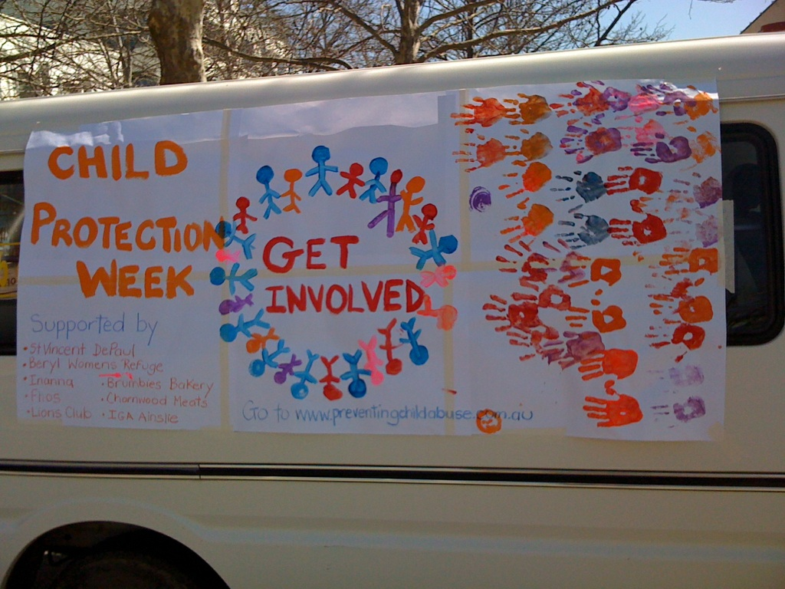

Angie Piubello
Child/Youth Support Worker

SERVICE DEMOGRAPHICS

This year the service accommodated 47 women with 84 children across all Beryl Women Inc. properties, 131 clients in total. This is a reduction in clients accommodated from last year, women and children are staying longer due to limited exit points, a large portion of these women had 1 accompanying child, exits points into public housing has been stalled due to a lack of available stock that meets the dynamics of these families, resulting in longer lengths of stay within the service and limited turn over in service users.

14.9% of women accessing the service came from other states and territories; this is a major reduction from the previous year which was 41%. The reduction could be attributed to the way in which we are assessing women who are seeking accommodation through the service, once a conversation is started, it is explained to the women the barriers in getting permanent accommodation in the ACT and the length of time this takes and what this means when residing in a women’s refuge, particularly when living in a shared space, once women are informed of these difficulties they often seek accommodation in the state/territory in which they are currently living in.

11% of women exiting the service were accommodated in other SAAP services, a decrease from the previous year which was 30%. Our statistics indicate that the number of women accommodated in public housing has increased during this financial year.

Only 4% of women found accommodation on the private rental market; this reflects an increase from 2008/09. Private rental is not an affordable option for women and their children as the majority are reliant on government benefits as their only source of income, however, during this year, the service accommodated women who were earning an income that allowed them to rent privately.

Beryl workers also provided outreach support to 33 women with 57 children during this financial year, of these families, only 10% were not accommodated in the service. Outreach support is provided to women and children who are no longer accommodated in the service or are seeking accommodation but due to a lack of accommodation, the service was unable to provide them with somewhere to stay. Outreach support included the following;
- Court & legal appointments;
- ACT housing and support letters;
- Referrals to other agencies;
- Support with children;
- Children attending groups at Beryl Women Inc.;
- Medical issues and
- Completing forms.

97 women with 148 children were turned away from the service, the majority of these were turned away due to a lack of accommodation, a smaller number did not meet the criteria of the service, all women who made contact with the service were offered a Pathways referral, some accepting and others choosing to self-refer.

The number of women from Sudan that were accommodated in the service has increased substantially during this financial year. The number of Aboriginal and/or Torres Strait Islander women seeking support with the service has declined dramatically during this time, this could be credited to Inanna Inc. who have specific accommodation targeted for Aboriginal and/or Torres Strait Islander families.

The following graphs provide some key demographic data about the families accommodated by Beryl Women Inc. during the 2009/2010 financial year – their cultural background, how they came to Beryl (who referred them), and where they went when they left the service.

Cultural Background

For the 2009/2010 financial year there has been an increase in the diverse range of cultural backgrounds of women accessing the service.

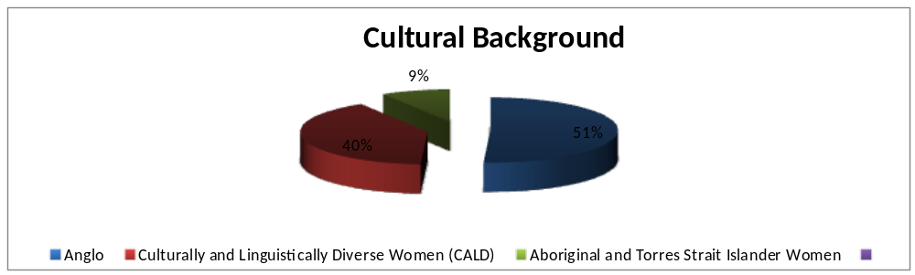
Anglo 29
Culturally and Linguistically Diverse 23
Aboriginal and Torres Strait Islander 5

Source of referrals

Domestic Violence Crisis Service continue to be the major source of referrals to the service during this financial year, self-referrals and referrals from other SNAHA services also remain consistent with previous years reporting.

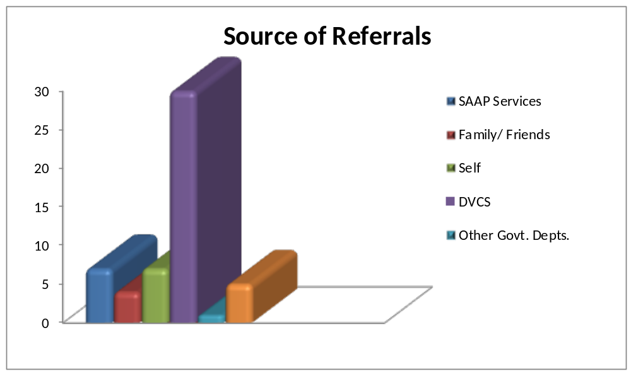
SAAP Services 7
Family Friends 4
Self 7
DVCS 30
Other Govt. Depts. 1
Other Non Govt. Depts. 5
Unknown 1

Destination after exiting from the service

During 2008/09, we have seen an increase in the number of women and children being accommodated in public housing, there has been a decrease in the number of families being accommodated in other SAAP services, and less number of women returning to an unsafe home environment, this
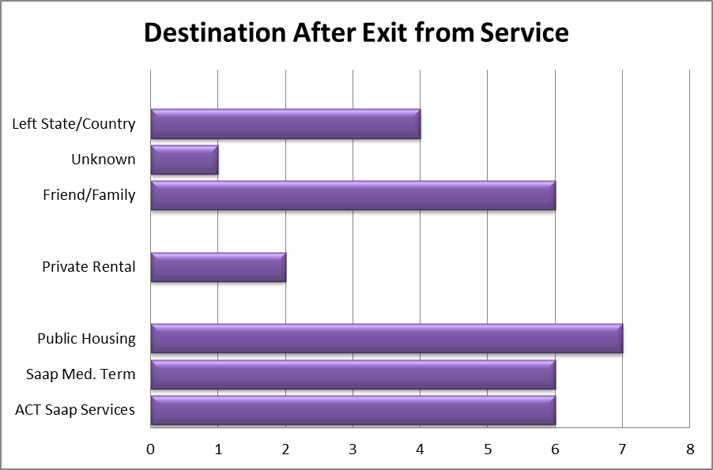

ACT SAAP Services 6
SAAP Med. Term 6
Public Housing 7
Private Rental 2
Family/Friends 6
Left State/Country 4
Unknown 1

Seven clients are still currently accommodated in our service.

Average Length of Stay
The average lengths of accommodated days are 4-13 weeks. The longest stay was 325 days (46.4 weeks) and the shortest being 1 day.

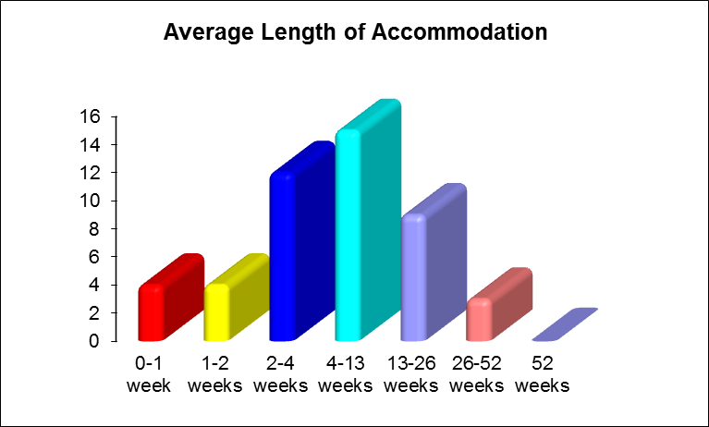

Two women and their 4 children are still accommodated

0-1 week 4
1-2 weeks 4
2-4 weeks 12
4-13 weeks 15
13-26 weeks 9
26-52 weeks 3
52 weeks 0

Seven women and their 13 children are still accommodated

